**AWS**

What is Cloud Computing?

Cloud computing is the on-demand delivery of compute, database storage, applications and other IT resources through a cloud services platform via the internet with pay-as-you-go pricing.  
Basically it is renting someone else’s computer to store files, to compute etc. and paying for it by the minute or by the hour.

Advantages of Cloud Computing –

* Trade Capital Expense for Variable Expense – Instead of having to invest heavily on data centers and servers before you know how you’re going to use them. With the cloud computing providers, you will need to pay only for what you use and how much you use.
* Benefit of massive economics of scale – We will never be able to match with Amazon or other cloud computing providers on how many servers they will be able to purchase so no use in competing with them rather to use their services.
* Stop guessing about capacity – Trying to build our own servers we may end up buying too much or too less. Whereas cloud providers can scale our business needs with no long-term contracts so we can increase or decrease capacity whenever required.
* Increased speed and agility
* Stop spending money on running and maintaining datacenters – let cloud service providers manage datacenters and so we can focus on the actual work.
* Go global in minutes – Deploy application in multiple regions around the world since AWS has datacenters all around the world which means low latency and better experience for customers.

Three types of cloud computing:

* IAAS – Infrastructure as a Service.   
  With **IaaS**, a provider supplies the basic compute, storage and networking infrastructure along with the hypervisor (a is software that creates and runs virtual machines) -- the virtualization layer. Users must then create virtual machines, install operating systems, support applications and data, and handle all of the configuration and management associated with those tasks. Examples of IaaS services are DigitalOcean, AWS and Google Compute Engine (GCE).
* PAAS – Platform as a Service.   
  With **PaaS**, a provider offers more of the application stack than IaaS solutions, adding operating systems, middleware (such as databases) and other runtimes into the cloud environment. PaaS products include AWS Elastic Beanstalk and Google App Engine
* SAAS – Software as a Service.  
  With **SaaS**, a provider offers an entire application stack. Users simply log in and use the application that runs completely on the provider's infrastructure. Typically, SaaS applications are completely accessible via internet web browser. SaaS providers manage all IT resources. Examples of SaaS include Salesforce, Dropbox and Google Workspace.

Three types of cloud computing deployments:

* Public cloud – A cloud-based application is fully deployed in the cloud and all parts of the application run in the cloud. Applications in the cloud have either been created in the cloud or have been migrated from an existing infrastructure to take advantage of the benefits of cloud computing. E.g., AWS, Azure, GCP
* Hybrid cloud - A hybrid deployment is a way to connect infrastructure and applications between cloud-based resources and existing resources that are not located in the cloud. It is a mixture of public and private cloud  
  E.g. – Website is hosted on public cloud, but databases are maintained in private.
* Private cloud or On-Premise - managed by the company's data center.

Most companies today are Hybrid cloud or Private cloud.

Region vs AZ vs Edge Location:

A **Region** is a geographical area. Each region consists of 2 or more Availability zones. Each AWS Region consists of multiple, isolated, and physically separate AZ's within a geographic area.  
An **Availability Zone** is basically multiple datacenters but as they are close together, they are counted as 1 availability zone.   
**Edge Locations** are endpoint for AWS which are used for caching contents. **Content caching** is a performance optimization mechanism in which data is delivered from the closest servers for optimal application performance. For example, **content** from a single server can be copied and distributed across various data centers and clouds.

The number of edge locations is greater than the number of Availability Zones, which is greater than the number of regions.

Choosing the right AWS Region should be based on –

* Data Sovereignty Laws – if the data to be stored has to be kept only withing a particular location for legal reasons.
* Latency to end users – determined by where majority of the users live
* AWS Service – some services may be available only in some particular locations so based on that the AWS Region can be chosen

**Support Levels offered by AWS**:

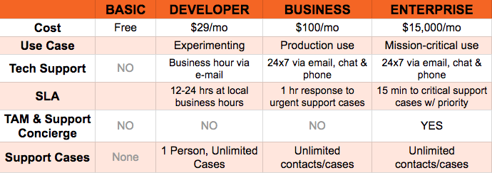

How to get automatic notification if your account bill goes over a particular value?  
We need to go into CloudWatch under Services> and create a billing alarm This creates an SNS topic which basically emails us if I would account bill goes over the particular threshold value.

Identity Access Management (IAM) - IAM allows you to create users, groups and roles, basically it’s a way to give access to AWS to your different users and groups. IAM is Global, it is not needed to specify a particular region when dealing with IAM.

AWS platform can be accessed in three different ways:

* via the console
* programmatically (using command line)
* using the software developers kit (SDK)

Root Account is the email address that is used to set up the AWS at account. The root account always has full administrator access. You should not give this account credential away to anyone instead create a user for each individual within your organization. You should always secure this root account using multifactor authentication (MFA)

**IAM – Identity Access and Management:**

A **group** is simply a place to store your **users**. Your users will inherit all permissions that the group provides. Example of group might be developers, System Administrator, human resource, finance etc.

To set the permission in a group you need to apply policy to that group, policies consist of JSON data. These are referred to as key value pairs you have your key such as name and then the value.

Best Practices for IAM:

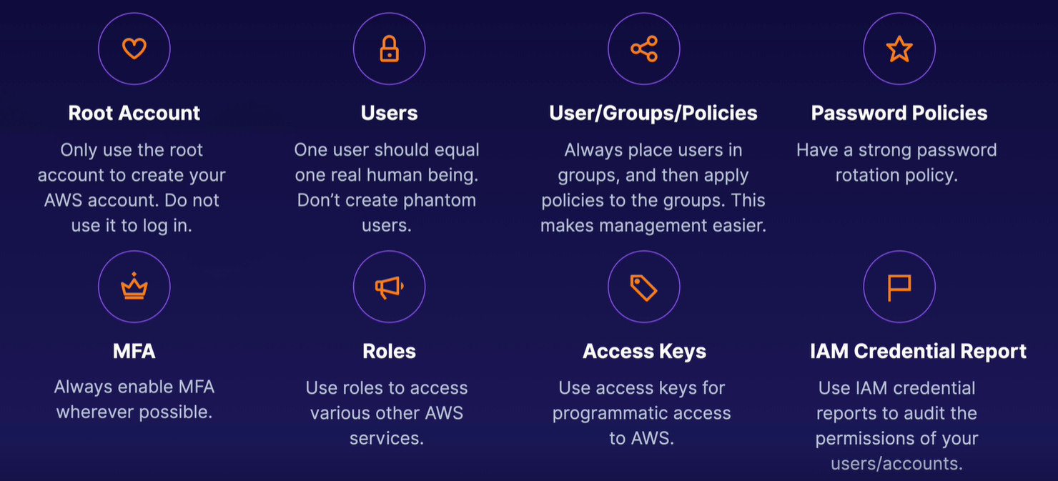

**IAM: Users and Groups**

* IAM is Identity and Access Management, it is a global service. In IAM we create users and assign them to groups.
* The Root Account shouldn’t be shared with anyone and for that reason we need to create users and assign them to groups.
* Users are people within your organization and can be grouped.
  + A new user has No Permission when first created.
  + New users are assigned Access Key ID and a Secret Access Key when first created, these are used to programmatically access AWS
* Groups can contain users, not other groups.
* Some users may not belong to any group or some users can belong to multiple groups, both are possible in AWS.

**IAM: Permissions**

We create users and group to allow users to use our AWS account and for that they need to have permissions.

* Users or Groups can be assigned to JSON documents called policies. Policies define what the user or group is allowed to do and help us define permission of the users.
* In AWS we don’t allow everyone to do everything. The Least Policy Principle is applied i.e., don’t give more permissions than a user need.

**IAM Policy Inheritance:**

* If we attach policy at the group level, then the policy gets applied to every member of that group and inherit the policy.
* Inline policy is a policy that is attached to a single user who does not belong to any group.

IAM Policy Structure:

A Policy Consist of –

* Version: this is the policy language version, which is being used, usually it is ”2012-10-17”
* Id: id helps us to identify the policy (optional field)
* Statement: one or more individual statement (required field)

Statement consists of –

* Sid: it is an identifier for the statement (optional field)
* Effect: specifies whether the statement allows or denies access (Allow, Deny)
* Principal: consist of which account/user/role to which this policy is applied to
* Action: list of actions or API calls that will be either denied or allowed depending on the ‘Effect’
* Resource: list of resource to which the action is applied to
* Condition: conditions for which this policy is on effect (optional field)

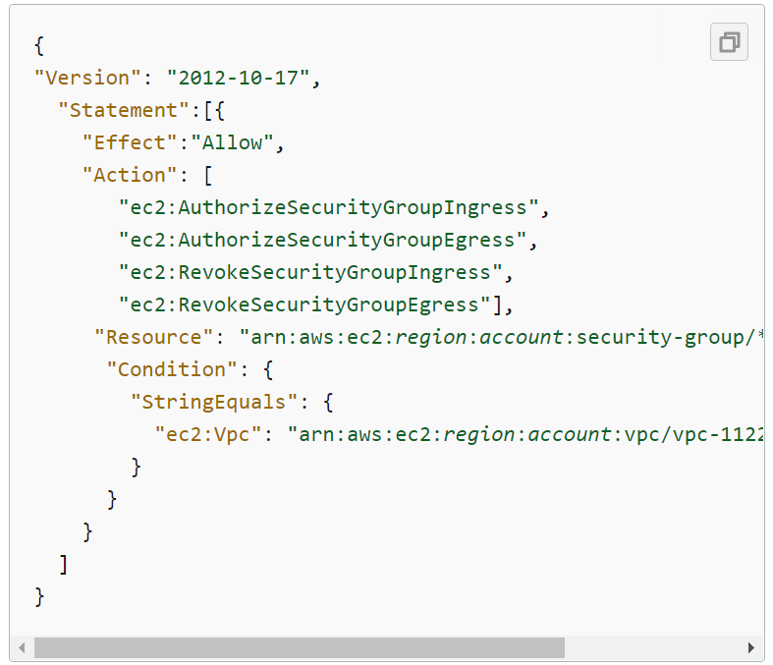

IAM: Password Policy

Below are the list of password policies that can be set up in AWS -

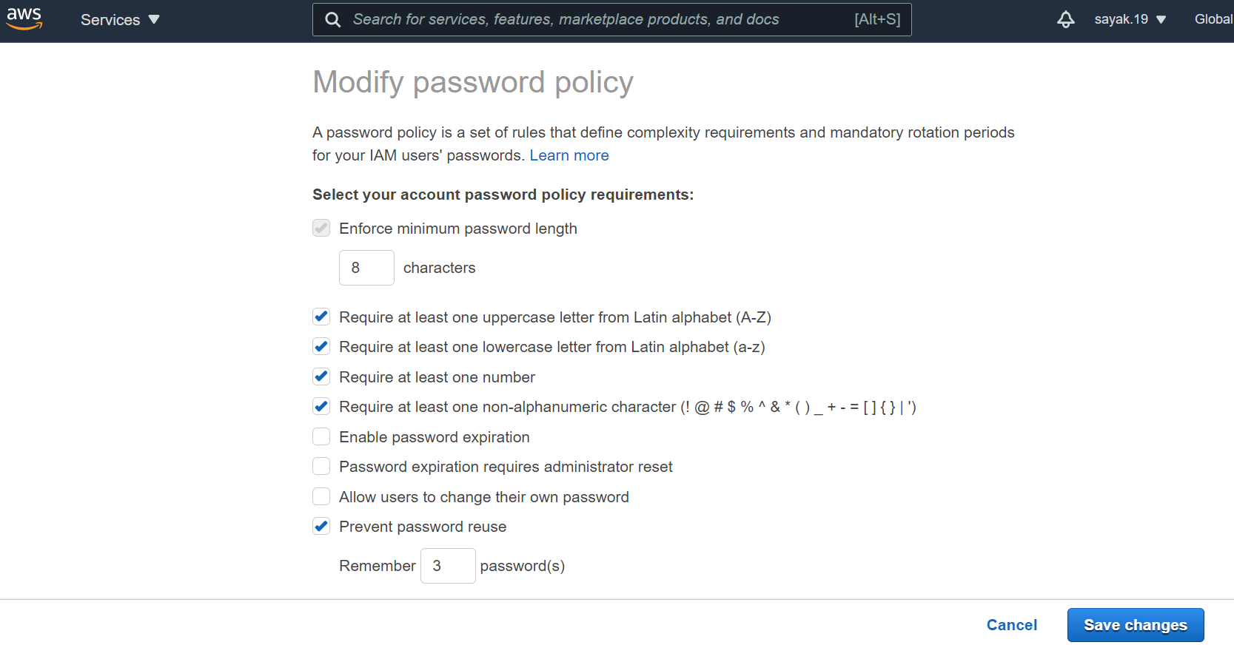

Multi Factor Authentication – MFA

* Users who have Admin Access can have access to your account and can possibly change configuration or delete resources in your AWS Account.
* To protect your Root Account and all your IAM users we need to set up MFA instead of using only password for authentication.  
  MFA = password you know + security device you own.

MFA device options in AWS

* Virtual MFA device –
  + Google Authenticator (phone only/single device)
  + Authy (multi device)

Supports for multiple tokens on a single device Some AWS services

* Universal 2nd Factor (U2F) Security Key –
  + YubiKey by Yubico (3rd party)

Supports for multiple root and IAM users using a single security key

* Other 3rd party MFA Devices

IAM Roles for Services:

* Some AWS services need to perform actions on our behalf on our account and for that they will need some kind of permissions. IAM roles allow applications to securely make API requests from instances, without requiring you to manage the security credentials that the applications use.
* We need to assign permissions to AWS services and to do so we create IAM Roles. IAM Roles are like users but they are not intended to be used by physical people but by AWS Services
* You can use IAM roles to delegate access to IAM users managed within your account, to IAM users under a different AWS account, to a web service offered by AWS such as Amazon Elastic Compute Cloud (Amazon EC2), or to an external user authenticated by an external identity provider (IdP) service that is compatible with SAML 2.0 or OpenID Connect, or a custom-built identity broker.

IAM Security Tools:

IAM Credential Report – This is an account level report that lists all your account’s users and the status of their various credentials. A Credential Report will show different information on password, access keys and MFA for all users in your account.   
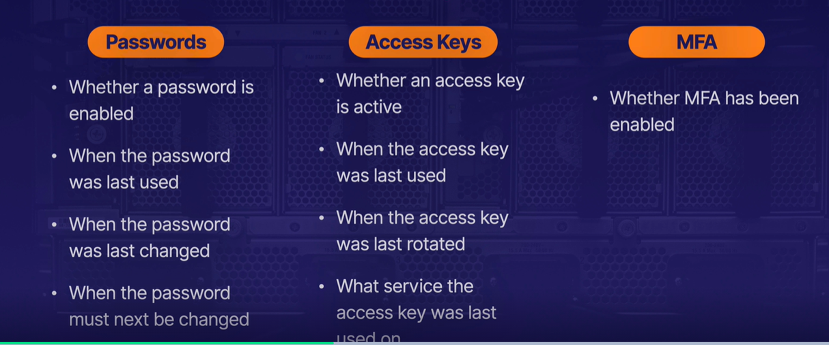

IAM Access Advisor – This is a user level report that shows the service permissions granted to a user and when those service were last used. Using this tool, we can determine which permission are not used by a user so as to remove those permissions and following the Least Permission principle.

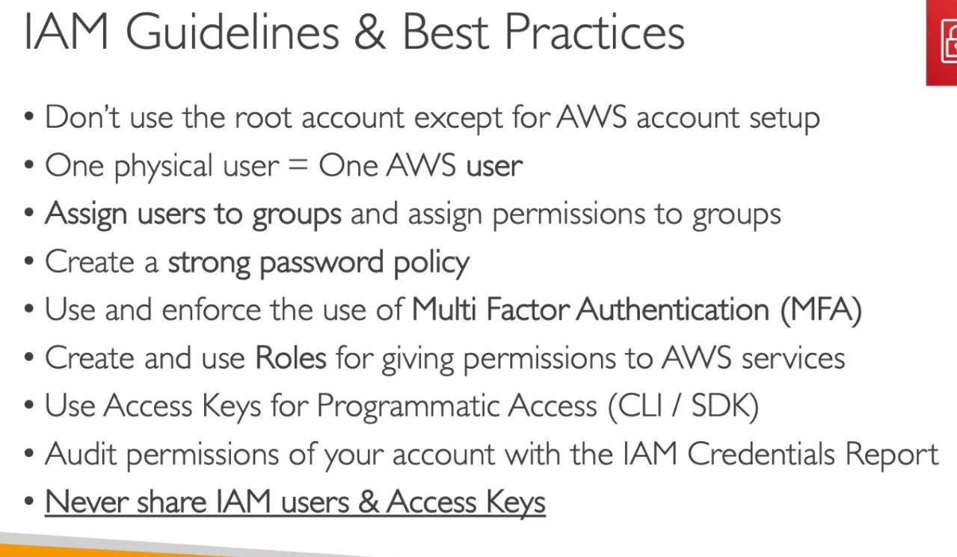

* 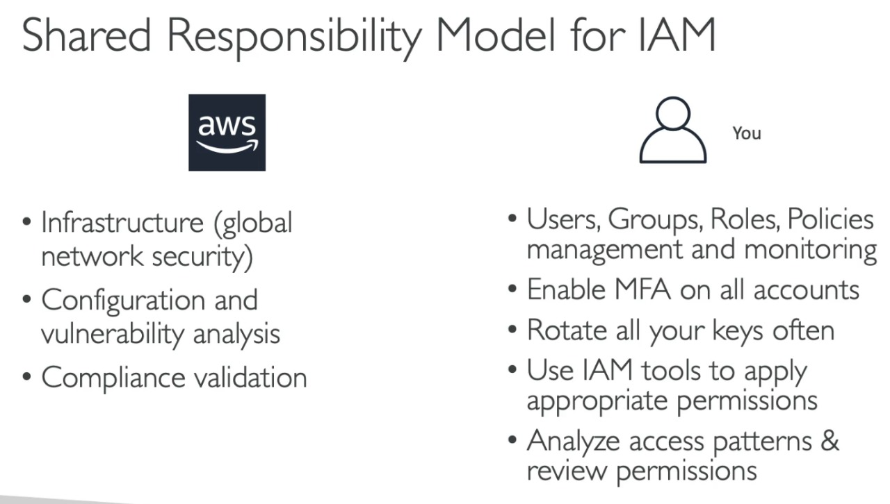

IAM Policy Simulator:

* It allows to test the effect of IAM policies and validate them before they are committed to production.
* It allows us to test policies which are already attached to existing users
* In the IAM Policy Simulator page the list of users for your AWS account can be found, any user can be selected for validation. After selecting a user, we need to select any Service and any respective Action and Run Simulation to test whether that user has sufficient access to perform that particular action.
* IAM Policy Simulator allows to Run Simulation on Users, Groups and Roles.
* You can access the IAM Policy Simulator Console at: <https://policysim.aws.amazon.com/>

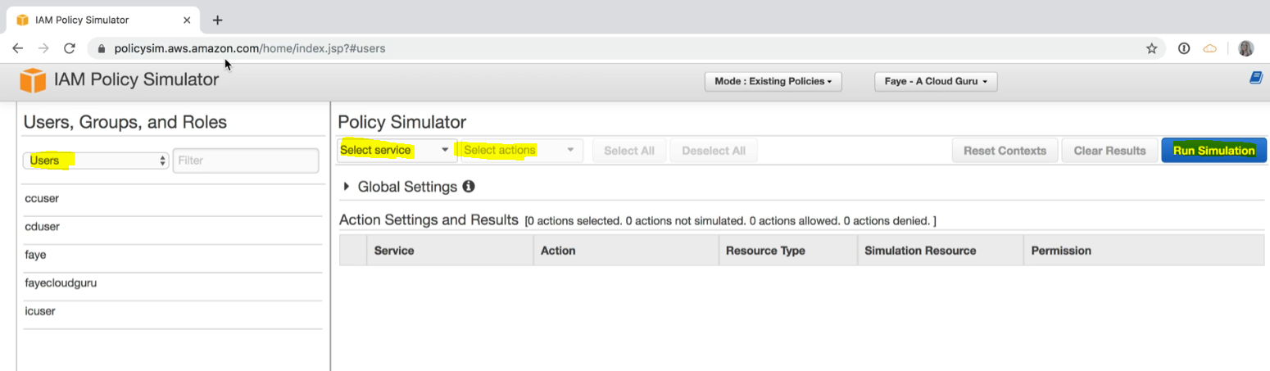

IAM Summary:

* Users: are mapped to a physical user, has a password for AWS Console
* Groups: contains users only
* Policies: JSON document that outlines permissions for individual users (inline) or groups.
* Roles: permissions for EC2 instances or other AWS services
* Security: MFA + Password policy
* AWS CLI: to manage your AWS services using command-line
* AWS SDK: to manage your AWS services using a programming language like python, ruby etc.
* Access Keys: used to access AWS suing the CLI or SDK
* Audit: IAM Credential Reports & IAM Access Advisor can be used.
* AWS Identity and Access Management (IAM) enables you to manage access to AWS services and resources securely. Using IAM, you can create and manage AWS users, groups, roles, and use permissions to allow and deny their access to AWS resources.

**EC2 – Elastic Compute Cloud:**

EC2 is a web service that provides resizable compute capacity in the cloud. Amazon EC2 reduces the time required to obtain and boot new server instance to minutes, allowing you to quickly scale capacity both up and down as your computing requirement change.

EC2 mainly consist in the capability of:

* Renting virtual machines (EC2)
* Storing data on virtual drives (EBS)
* Distributing load across machines (ELB – Elastic Load Balancer)
* Scaling the service using an Auto Scaling group (ASG)

EC2 sizing and configuration options:

What can we choose for our EC2 instances i.e., the virtual servers that will rent from AWS –

* Operating system: Linux, Windows or Mac OS
* How much CPU power and cords do we need?
* how much RAM we need?
* how much software space
  + if storage is going to be Network-Attached (ESB & EFS)
  + if storage is going to be Hardware-Attached (EC2 instance store)
* Network speed: speed of the network card, what public IP do we want
* Firewall rules: security group
* Bootstrap script (to configure the instance at first launch): EC2 User Data

EC2 User Data –

* It is possible to bootstrap our instances using and EC2 user data script
* bootstrapping means launching commands when the machine/instance start
* that script is only run once when it first starts and it will never run again
* PC to user data is used to automate boot task such as:
  + Installing updates
  + installing software
  + downloading common files from the Internet
  + etc.
* The EC2 User Data Script runs with the root user so any command we have will have the sudo rights

**EC2 Instance Types**:

* Different types of EC2 instance can be used that are optimized for different use cases (ref: <https://aws.amazon.com/ec2/instance-types/>)
* Each type of instance has different families having naming conventions like -   
  instance name – m5.2xlarge  
  where, m = instance class  
  5 = generation of instance   
  2xlarge = size withing the instance class
* Instance type refers to the underlying hardware that is used to host your EC2 instance. It determines the capabilities of the hardware like the CPU’s computing capability, memory and storage capacity etc. Each EC2 instance type offers a different compute, memory and storage capabilities.
* General Purpose:
  + Great for diversity of workloads like web server or code repositories
  + Good balance between: Compute, Memory and Networking
* Compute Optimized:
  + Great for compute intensive tasks that require high performance processors like:
    - Batch processing workloads
    - Media transcoding
    - High performance web servers
    - High performance computing (HPC)
    - Scientific modeling & machine learning
    - Dedicated gaming server
* Memory Optimized:
  + Fast performance for workloads that processes large datasets in memory
  + Use cases:
    - High performance, relational/non-relational databases
    - Distributed web scale cache stores
    - In-memory databases optimized for BI (business intelligence)
    - Application performing real-time processing of big unstructured data
* Storage Optimized:
  + Great for storage intensive tasks that require high, sequential read and write access to large data sets on local storage
  + Use cases:
    - High frequency online transaction processing (OLTP systems)
    - Relational and NoSQL databases
    - Cache for in-memory databases
    - Data warehousing applications
    - Distributed file system

AWS EC2 Instance Comparison website: <https://instances.vantage.sh/>

**Introduction to Security Groups:**

* Security groups at the fundamental of network security in AWS
* They control how the traffic it's allowed into or out of the EC2 instances
* Security groups only contains allow rules i.e., we cannot block individual IP address or port
* Security groups can have rules that is reference either by IP address i.e., where your computer is from or by other security groups.

Understanding how Security Groups work-

Let's take an example we are on our computer that is connected to the public internet and we are trying to connect to our EC2 instance from our computer. We are going to create a Security Group around our EC2 instance, and this Security Group is going to have rules which will determine whether or not some inbound traffic from outside will be allowed in our EC2 instance or not and also if our EC2 instance is allowed to send outbound traffic into the internet.

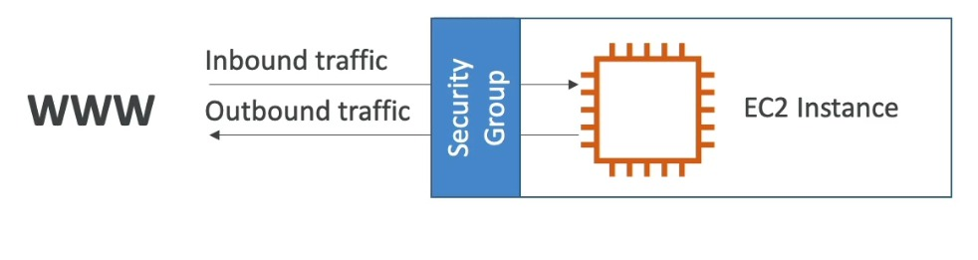

* Security groups are acting as firewall on the EC2 instance
* they regulate:
  + access to port
  + authorize IP ranges
  + Control the inbound network that is from outside to instance
  + control the outbound network that is from the instance to outside

Security Group Diagram:

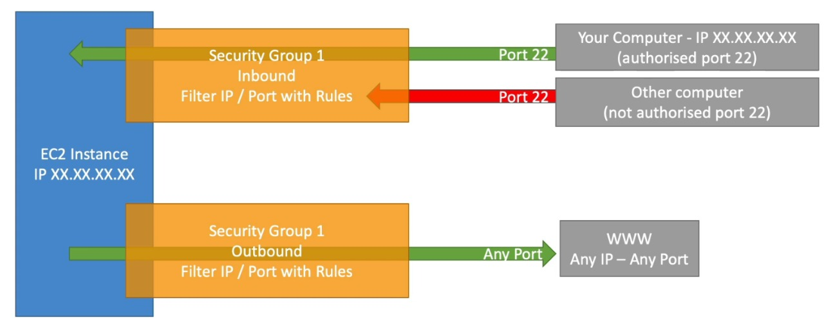

Above EC2 instance has one security group attached to it that create rules for inbound and outbound traffic. ‘Your Computer’ is authorized in port 22 i.e., IP of the computer is authorized to access the EC2 instance but someone else’s computer having different IP address will not have access to our EC2 instance since they are not authorized and will get a timeout error. The firewall/security group will block it and the request will not even reach our EC2 instance.

For outbound request by default our EC2 instance will be allowed to access any websites over the internet i.e., none of the request will be blocked.

* security groups can be attached to multiple instances it is not a one-to-one relationship between security groups and also EC2 instances can also have multiple security group attached to it.
* Security groups locked down to a region /VPC combination i.e., if you switch to another region you have to create a new security group or if you create a new VPC then also you need to create another security group.
* Any changes made to Security Groups takes effect immediately
* The security group leaves outside the EC2 instance that is if the traffic is blocked the EC2 instance won't even see it
* It is good to maintain one separate security group for SSH access
* If your application is not accessible due to timeout error, then it is a security group issue
* If your application gives a “connection refused” error, then it's an application error or it’s not launched properly
* All inbound traffic is blocked by default
* All outbound traffic is authorized by default
* Security Groups are STATEFUL i.e., if we open an inbound rule to allow a particular traffic in then that traffic is automatically allowed back out. (if we open inbound for HTTP on port 80 then outbound is also generated even if it does not show up)

Referencing other Security Groups:

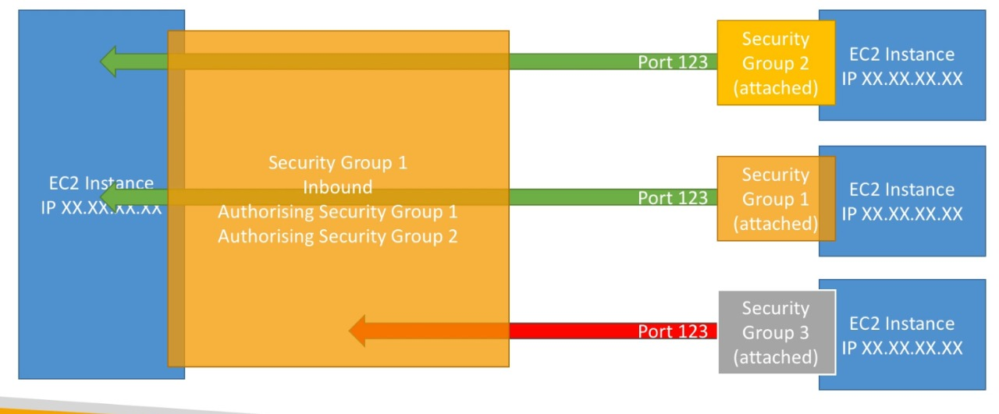

*Regardless of the IP of our EC two instances if they have the right security group attached to them then they will be able to communicate with other EC2 instances having same Security group.

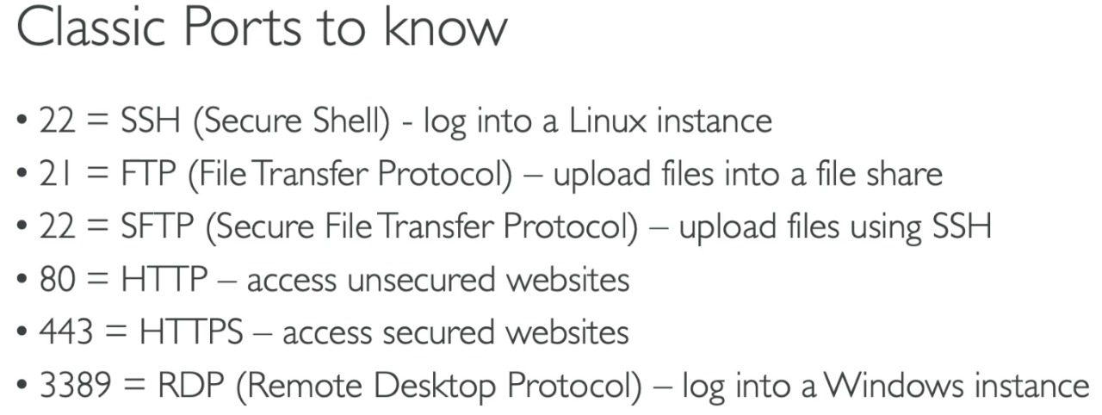

**1.**[IP address](https://www.geeksforgeeks.org/introduction-of-classful-ip-addressing/)**:**  
An Internet Protocol address (IP address) is the logical address of our network hardware by which other devices identify it in a network. IP address stands for Internet Protocol address which is an unique number or a numerical representation that uniquely identifies a specific interface on the network. Each device that is connected to internet an IP address is assigned to it for its unique identification.

Addresses in IPv4 are 32-bits long example,

12.244.233.165

And Addresses in IPv6 are 128-bits example,

2001:0db8:0000:0000:0000:ff00:0042:7879

**2.**[Port Number](https://www.geeksforgeeks.org/tcp-ip-ports-and-its-applications/)**:**  
Port number is the part of the addressing information used to identify the senders and receivers of messages in computer networking. Different port numbers are used to determine what protocol incoming traffic should be directed to. Port number identifies a specific process to which an Internet or other network message is to be forwarded when it arrives at a server. Ports are identified for each protocol and It is considered as a communication endpoint.

Ports are represented by 16-bit numbers. 0 to 1023 are restricted port numbers are as they are used by well-known protocol services. 1024 to 49151 are registered port numbers means it can be registered to specific protocols by software corporations and in last 49152 to 65536 are used as private ports means they can be used by anybody.

Launching an EC2 Instance in AWS:

* To launch an EC2 instance first we need to choose an AMI (Amazon Machine Image)- An AMI is a template that contains the software configuration (operating system, application server, and applications) required to launch your instance. You can select an AMI provided by AWS, our user community, or the AWS Marketplace; or you can select one of your own AMIs.
* Next, we need to choose the instance type
* We need to configure our instance details  
  While configuring our instance details, under Advanced Details we can give User Data – the EC2 user data is a script that will run only during the first boot of our EC2 instance
* We need to Add Storage which will determine how much storage will be available on our EC2 instance
* We can Add Tags or skip
* Create Security Group and attach a rule to it.
* When we launch our EC2 instance we need to select a Key pair, the key pair will be used to SSH to login to our instance

SSH into EC2 Instance:

From windows we can log in to our EC2 instance using two methods, one is using EC2 Instance Connect and other is using Putty.  
Using Putty we need to provide the Key-Pair which we downloaded to SSH into our instance. We also need to change the permission of our key pair 🡪chmod 400 else we will get an error

*We can attach Rules to EC2 instances like we attach rules to users. Select the EC2 instance>Action>Security>Modify IAM roles.

Choosing or generating a key pair while launching EC2 instance - A key pair consists of a public key that AWS stores, and a private key file that you store, and it will allow you to connect to your instance securely. You can use the same public key for multiple instances (basically it is like a no. of locks having the same key so keep the kay safe if you are using the same lock in multiple places)

* EC2 instance termination is turned off by default

AWS CLI – we can interact with AWS from anywhere in the world by using AWS CLI. To use AWS CLI we need to SSH into our EC2 instance and that EC2 instance should have appropriate IAM Roles for the service we want to use from EC2 Instance using AWS CLI. We can also configure our user credentials i.e., Access Key and Secret Access Key in the EC2 instance using command ‘aws configure’ to use our service (to which our user has access to) using AWS CLI, but it is not at all recommended. Roles allow you to provide access without the use of access key IDs and secret access keys. After having access, we can access any AWS service from that EC2 instance.

AWS CLI Pagination – if you see errors like “timed out”, or errors related to too many results being returned,

* Adjust the pagination od CLI results to avoid errors generated by too many results

CLI still retrieves the full list but performs a larger no. of API calls in the background and retrieves a small no. of items with each call.

EC2 purchasing options:

* On-Demand Instances: short workloads and predictable pricing
  + Pay for what you use:
    - Linux- billing per second, after the first minute
    - All other operating system (like Windows)- billed per hour
  + Allows you to use a fixed rate by the hour with no commitment
  + Has the highest cost but no upfront payment
  + No long-term commitment
  + Recommended for short-term and uninterrupted workloads where you can’t predict how application will behave.

When we know we need to use a server for a very long time we can use –

* Reserved (reserved for 1 year or 3 year) –
  + Reserved Instances: Provides you with a capacity reservation and offers a significant discount on the hourly charges for an instance. Reserved instances are the most economical option for long-term workloads with predictable usage patterns. (like a database)
    - Up to 75% discount compared to On-demand
    - Reservation period: 1year = +discount | 3 year = +++discount
    - Purchasing options: no upfront (pay monthly) | partial upfront (partial payment at the beginning then pay monthly) = + discount | All upfront = +++ discount
    - We need to reserve a specific instance type which we cannot change in future and if we are reserving a instance then it is recommended for use of steady-state usage application (like database)
  + Convertible Reserved Instance: long workloads with flexible instances where we can change EC2 instance type overtime
    - This gives a bit less discount i.e., up to 54%
  + Scheduled Reserved Instance: when we know we need to launch it withing a specific time window that you reserve i.e., when it is required for a fraction of a day/week/month.
    - We need to commit for 1-3 years
* Spot Instance: Enables you to bid whatever price you want for instance capacity, providing for even greater savings if your applications have a flexible start and end time. Used short workloads, cheap can lose instance (less reliable)
  + Can get a discount of 94% compared to On-demand instance; the MOST cost-efficient instance in AWS
  + But the particularity of this instance is that you can loose them at any point of time if the max price you are willing to pay for that instance is less than the current spot price (spot price changes over time like stock market prices)
  + Useful for workloads that are resilient to failure like
    - Batch jobs,
    - Data analysis,
    - Image processing,
    - Any distributed workload (if one server fails other server can take the load),
    - Workloads for flexible start and end time
  + Not suitable for critical jobs or database
* Dedicated Hosts: An Amazon EC2 Dedicated Host is a physical server with EC2 instance capacity fully dedicated to your use. Dedicated Hosts can help you address compliance requirements and reduce cost by allowing you to use your existing server bound software license.
  + These hosts will be allocated for your account for a 3-year period reservation
  + They are more expensive as you are getting a full server for yourself
  + They are useful for companies that have strong regulatory, or compliance needs i.e. the server will not be a shared server.

**Systems Manager** for EC2 Instance – used to manage fleets of EC2 instances. It is installed in each VM/EC2. Used to run commands, install updates/patches in multiple EC2 instances at once.

**EBS Volume:**

* An EBS (**Elastic Block Store Volume**) is a network drive that you can attach to your EC2 instance while they run
* It allows your instant to persist data, even after the instance is terminated and we can recreate an instance and mount with the same EBS volume from before and get back our data.
* EBS Volumes are bound to a specific availability zone and the EC2 instance it is attached to should be in the same AZ.
* They are Network drive (i.e., not physical drive)
  + We can think of EBS Volumes as a “Network USB Stick” where we can detach it from one instance and attach it to another instance very quickly
  + It uses the network to communicate the instance, which means there might be a bit of latency
* It’s locked to an Availability zone, to move it we first need to snapshot it.
* EBS Volume have a provisioned capacity,
  + You get billed for all the provisioned capacity
  + You can increase the capacity of the drive overtime if you want to have better performance or more size
* EBS Root Volumes of AMI’s can be encrypted. Additional EBS volumes can also be encrypted.

EBS – Delete on Termination attribute –

Delete on Termination attribute controls the EBS behavior when the EC2 instance is terminated to which it is attached

* by default, the root EBS volume is deleted
* by default, any other attached EBS volume is not deleted

But we can control this behavior in the AWS console/AWS CLI, we can preserve the root volume when instance is terminated and later attach it to some other instance.

**EBS Types**:

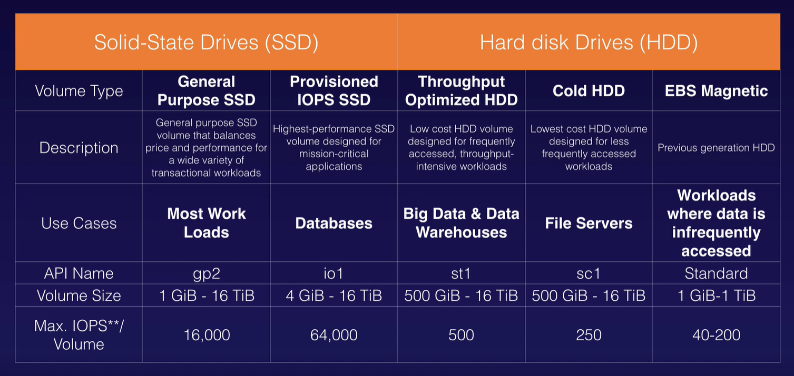

gp2/gp3 – suitable for Boot Disks and general-purpose applications which are not latency sensitive. gp3 is the latest version General purpose SSD

io1/io2 – it is the high performance and most expensive option. Designed for i/o intensive applications like large databases and latency-sensitive workloads. io2 is the latest version of Provisioned IOPS SSD

io2 Block Express – this is a new offering from AWS, it is a SAN(Storage Area Network) in the cloud provident the highest performance and sub-millisecond latency. Uses EBS Block architecture. Great for large, critical, high performance applications.

optimized HDD (st1) – great for storing huge amount of data which you want to access frequently. Cannot be a boot volume.

**EBS Snapshot:**

* You can create a snapshot of your EBS volume (basically a backup) at any point of time which will preserve the current state of the EBS Volume
* The Snapshot is stored in S3.
* Snapshots are incremental i.e., if we create a snapshot then add some files and again create snapshot then only the new files will move to the S3 not the entire volume will be copied again.
* While taking a backup of EBS volume it is not necessary to detach the volume to do snapshot, but it is recommended just to make sure everything is clean in your EBS Volume
* Snapshots can be copied across Availability Zones or Regions (Actions>Copy)

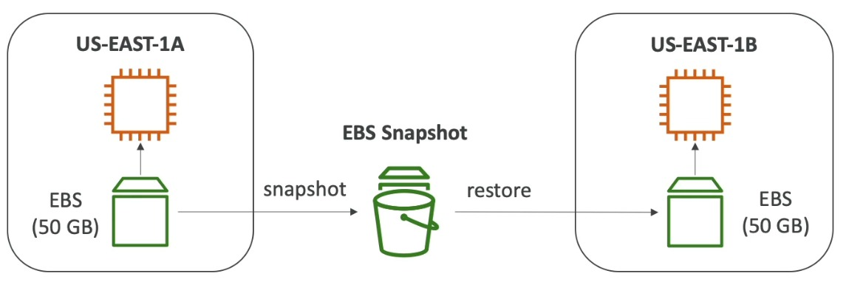

* The Snapshot can also be used to create an AMI which can be copied to any AZ and also from which we can create an EC2 Instance in any AZ.
* Snapshot can also be used to create a Volume in any AZ
* Volume created from an Encrypted snapshot will be an Encrypted volume and vice-versa.

**EFS (Elastic File Storage):**

It is a virtual disk that can be attached to EC2 (same as EBS). The difference with EBS is the size of the disk scales up and down depending on usage.

**Amazon Machine Image (AMI) Types**:

AMI can be selected based on –

* Region
* Operating system
* Architecture (32 bit or 64 bit)
* Launch permission
* Storage of the root device
  + Instance Storage (EPHEMERAL STORAGE)
  + EBS Backed Volumes

All AMIs are categorized as either backed by Amazon EBS or Instance Store

Backed by Amazon EBS Volume – the root device for an instance launched from that AMI is an EBS Volume created from an EBS Snapshot

Backed by Instance Storage - the root device for an instance launched from that AMI is an Instance Store volume created from a template stored in Amazon S3.

* If we want multiple instance store volumes, we can add them only before launching our Instance. After launching the instance, we can only add EBS Volumes
* Instance Store volumes are sometimes called EPHEMERAL STORAGE because if it is stopped you will lose all your data
* EBS backed volumes can be stopped and you will not lose your data
* By default, both ROOT volumes will be deleted on termination. However, with EBS volume, you can at least choose to keep the root device volume you can’t do that with instance store.

**S3 – Simple Storage Service:**

* It is an infinitely scalable storage which can be used for – Backup and Storage, Disaster Recovery, Archive data, Hybrid cloud storage etc.
* It is not suitable to install an operating system or run a database on.
* Amazon S3 contains files also called objects and they're stored in directories also called buckets
* S3 is used for storing static data i.e., which will not change over time or can be used for hosting static web pages.
* A HTTP 200 code is returned as a response if the upload to S3 is successful.
* While creating a S3 bucket we need to choose a region – and whenever we upload an object it is automatically replicated across different AZ in that region. So, availability is 99.99%

Bucket:

* Buckets must have a globally unique name i.e., across all regions and all accounts in AWS the buckets must be uniquely named
* Buckets are defined at a regional level, though S3 looks like a global service but buckets are created for a specific region
* Naming Convention –
  + No upper case
  + No underscore
  + 3-63 characters long
  + Must not be an IP
  + Must start with lowercase letter or number

Objects:

* In an S3 bucket objects(files) are stored and they are stored in key-value pairs.
* The key represents the full path to the object. E.g. – s3://my-bucket/my_file.txt | s3://my-bucket/my_folder1/another_folder/ my_file.txt
* The key is composed of prefix + object name - s3://my-bucket/my_folder1/another_folder/ my_file.txt
* The value is simply the data that is being stored.
* There is no concept of “directories” within buckets there are just keys with very long name that contain slashes (/)
* The max Object size is 5TB but a single object cannot be uploaded if its more than 5GB, in that case we need to use ‘Multipart Upload capability’
* Objects also have Version Id (which is important when Versioning is enabled in the S3 bucket) and Metadata.
* Object URL is created for each object which can be used to access the files over the internet (if it has public access)

Data Consistency Model for S3:

* Read after Write consistency for PUTS of new Object – if you write a file and read it immediately afterwards, you will be able to view the data.
* Eventual Consistency for overwrite PUTS and DELETES - If you update an existing file or delete a file and read it immediately, you may get the older version or you may not. Basically, changes to object can take a little bit of time to propagate.

S3 Security:

* User based
  + IAM Policies – we can define IAM users and assign IAM policies to allow them to access S3 buckets. The IAM Policy will define which API calls should be allowed for a specific user from IAM console
* Resource based
  + Bucket Policy – it is a rule directly attached to the S3 bucket to allow or deny request coming from other account. It is a bucket wide rule from the S3 console and allows cross account
  + Object Access Control List (ACL)/Object Policies – finer grain, we can define at object level who can do what. Applies to individual files.
  + Bucket Access Control List (ACL) – rarely used

 AWS recommends that you use **S3 bucket policies** or **IAM policies** for access control. Amazon S3 access control lists (ACLs) are a legacy access control mechanism that predates IAM. By default all newly created buckets are private.

An IAM principle can access a S3 object if either the IAM policies allow it OR if the Resource based policy allows it. There is no explicit DENY in the combined policy.

* If we want to give access to all public users over the internet to access our files in S3 bucket, then we can attach an S3 bucket policy to our S3 bucket which will allow public access.
* If we want to give an IAM user access to our S3 bucket, then we can attach an IAM policy to the user granting the user access to our S3 bucket and in this case it is not required to attach a S3 bucket policy to our S3 bucket.
* If we want to give a EC2 instance access to our S3 bucket, then we can create an EC2 Instance Role and attach IAM permissions to that EC2 Instance Role granting the EC2 instance access to the S3 bucket.
* If we want to give and an IAM user having a different AWS account access to our S3 bucket we can create an S3 bucket policy which will allow cross-account access and when defined correctly users from other AWS account will have access to our S3 bucket.

**S3 Encryption:**

Enforcing server-side encryption can be done in two ways,

* Using the AWS Console while creating S3 bucket we can select the encryption setting we want to keep. Amazon S3 server-side encryption uses one of the strongest block ciphers available, 256-bit Advanced Encryption Standard (AES-256)
* Using Bucket Policy also we can enforce encryption but its somewhat complicated.  
  Every time a file is uploaded to S3 a PUT request is initiated, if the file is encrypted then that information can be found in the PUT request.

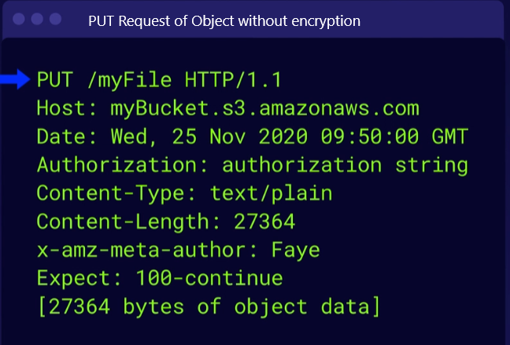 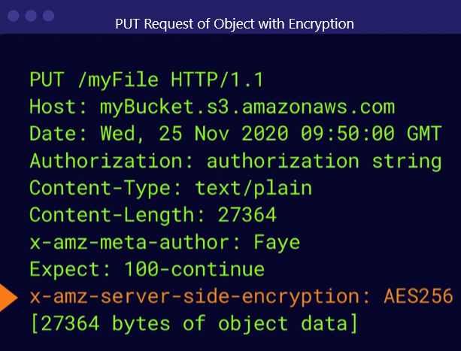

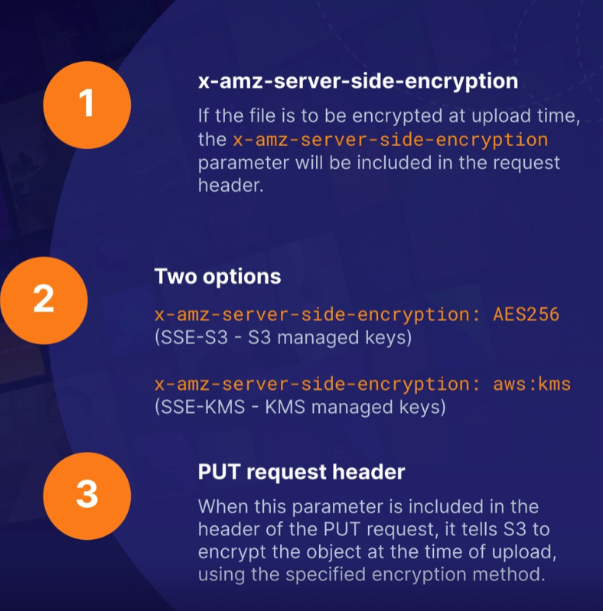 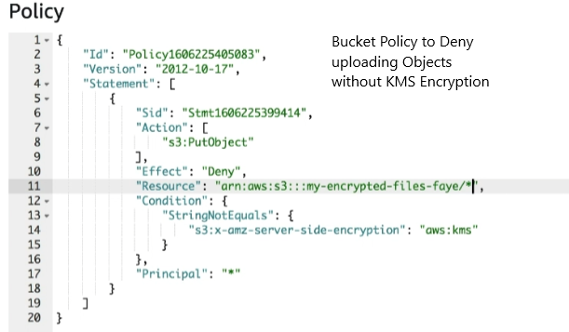

Explicitly denying requests that are identified as "aws:SecureTransport": "false" would deny requests that are using HTTP and are unencrypted.

**S3 Bucket Policies**:

* They are JSON based policies (similar to IAM policies)
* Use of S3 Bucket Policy – Grant public access to the bucket – Force objects to be encrypted at upload – Grant access to another account also called Cross-Account access

To creating a public bucket policy, we need to go to that S3 bucket which we want to make as public and go into Permissions tab and we need to create a Public Bucket policy. But to create a Public Bucket policy first we need to disable Block all Public Access settings.

* Amazon S3 – Versioning: We can enable versioning of files in Amazon S3, it is enabled at the bucket level. To enable versioning, we need to go to our S3 Bucket and under Properties we need to enable Bucket Versioning. After enabling versioning if we re-upload the same object a new version will be created for it.
  + Great backup tool
  + Versioning cannot be disabled – once enabled, versioning cannot be disabled it can only be suspended
  + Integrates with Life Cycle rule
  + Versioning can be used with MFA i.e. people cannot go and delete an object unless they have 2-factor authentication.
* **S3 Access Logs**: For audit purpose, we may want to log all the request coming into our S3 bucket for this we need to enable logging. Any request made to our S3 bucket, from any account, authorized are denied will be logged into another S3 bucket (logging bucket)(can be a S3 in different AWS Account). Access Logs are not enabled by default, to enable logging first we need to create another S3 bucket and then go to Properties of our S3 bucket and under properties we need to enable Server Access Logging and specify the target bucket that we just created.
* Creating a Serverless Static Website using S3:

To create a website from our S3 bucket first we need to disable all Block Public Access settings this will unblock other users over the internet trying to access our S3 bucket. Now we need to make our index.html and error.html (i.e. all webpages) public. We can do this either by individually selecting an object>going to Action>make Public or we can make all the objects in our bucket public by creating a Bucket Policy defining all objects to be public. When all objects are public and S3 bucket is accessible we need to enable Static Website Hosting (under Properties) and mention the index and error page and this will make our S3 bucket as a static website and also create a url to access this website. (Dynamic websites cannot be hosted on S3)

Below is an example of a Bucket Policy we can either manually type it or use the Policy Generator tool to create it.

Resource defines the S3 Bucket name, Principle defines the object name (* defines all objects), Action defines set of actions that is defined.

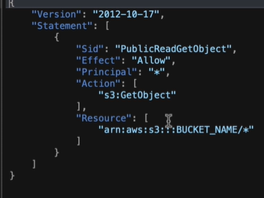

**S3 Bucket Cross Region Replication** – It will copy content of one bucket to another bucket asynchronously  
To enable replication go to main bucket>Management>Replication Rule>Create Replication Rule and we need to mention the rule name and the S3 bucket where we want to replicate.

* versioning should be enabled in both source bucket and destination bucket
* buckets can be in different accounts
* proper IAM permissions need to be given to S3 bucket

CORS (Cross Origin Resource Sharing) – this allows files in one bucket to refer to files in another bucket. Cross-origin resource sharing (CORS) defines a way for client web applications that are loaded in one domain to interact with resources in a different domain. With CORS support, you can build rich client-side web applications with Amazon S3 and selectively allow cross-origin access to your Amazon S3 resources.

**Amazon S3 Transfer Acceleration**:

Enables Fast, easy, and secured transfers of files over long distance between user and S3 bucket. Transfer Acceleration takes advantage of Amazon CloudFront globally distributed Edge locations.

**S3 Storage Classes**: (we can change storage class on the fly)

* S3 Standard – General Purposes
  + 99.99% Availability and is used for frequently accessed data
  + Data is stored redundantly across multiple devices in multiple facilities (>=3 AZs):
  + Perfect for frequently accessed data
* S3 Standard – Infrequent Access (S3-IA)
  + Suitable for data that is less frequently accessed, but requires rapid access when needed
  + Data is stored in multiple facilities (>=3 AZs):
  + Lower cost compared to Amazon S3 Standard
  + Used to store data for disaster recovery, backups
  + Minimum storage duration: 30 days
* S3 Intelligent-Tiering
  + Cost optimized by automatically moving object between two access tiers( frequent & infrequent access) based on changing access patterns
  + Automatically moves your data to the most cost-effective tier based on how frequently you access each object.
  + User Machine Learning
* S3 One Zone – Infrequent Access
  + Same as S3 IA but data is stored in a single AZ
  + Lower cost compared to S3 IA
  + Minimum storage duration: 30 days
* Amazon Glacier & Glacier Deep Archive
  + Low-cost object storage meant for archiving or backup
  + Optimized for data that is very infrequently accessed
  + You pay each time you access your data
  + Based on the tier we have chosen did a various retrieval options and fees for the retrieval
  + Amazon Glacier Deep Archive is the cheapest S3 bucket storage class, but it has very long retrieval time (12-48 hrs.) whereas Amazon Glacier’s retrieval time is minutes to hours.
  + Minimum storage duration for Glacier : 90 days, Minimum storage duration for Glacier Deep Archive: 180 days
* Glacier Instant Retrieval is designed for long-lived data, accessed approximately once per quarter with millisecond retrieval time. It is suitable for long-term archiving of data and supports millisecond retrieval times

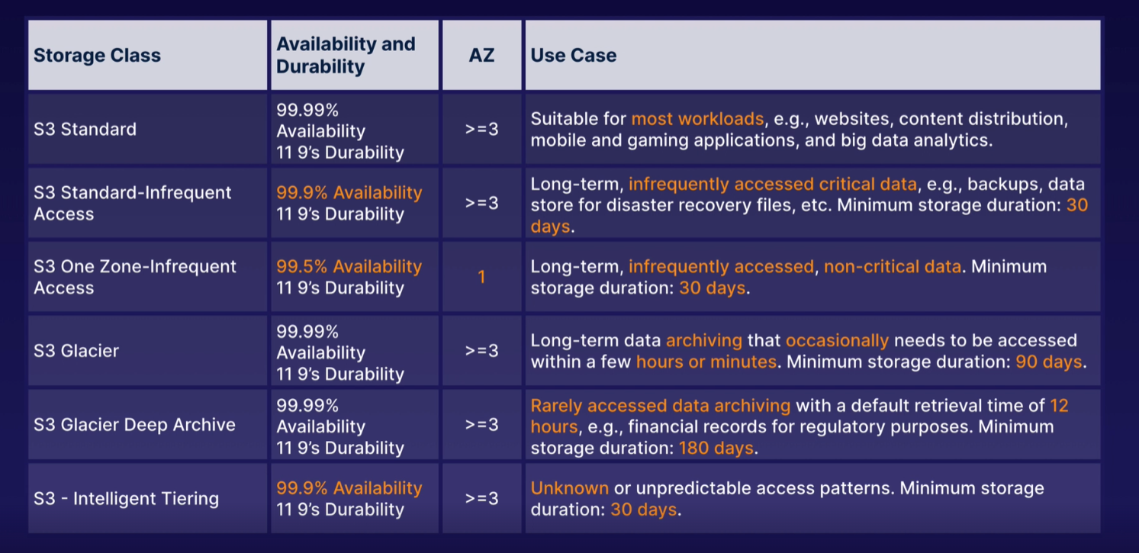

AWS Snow Family for Data Migration:

* It is a way to perform data migration using offline devices. If migration over the internet takes more than week to transfer the data, then use Snowball devices.
* These are highly secured, portable devices to collect and process data at the edge and migrate data into and out of AWS

Devices in Snow Family –

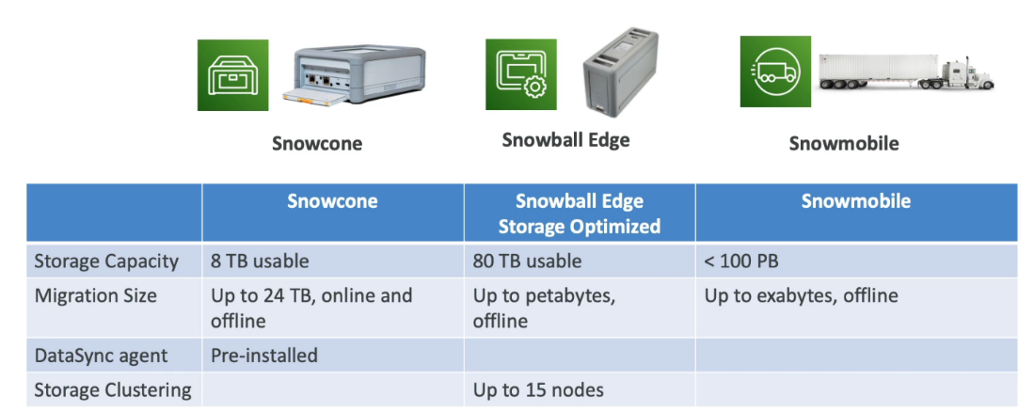

Snow Family – Usage Process:

* Request snowball devices from the AWS console for delivery
* install the snowball client/AWS OpsHub on your server
* connect to snowball to your server and copy files using the client
* ship back the device when you are done (goes to the right AWS facility)
* the data will be loaded into an S3 bucket
* the snowball will be completely wiped after that

Use of Snow Family in Edge Computing –

* Edge Computing is when you process data while it's being created on an edge location
* Edge location is any location that does not have access to internet, but they can produce data
* We setup a Snowball Edge/ Snowcone device to do edge computing

AWS OpsHub –

* Earlier to use Snow Family devices we need to use CLI
* But now we can use AWS OpsHub – a software we install in our computer/laptop to manage the Snow Family Devices

Storage Gateway:

* Hybrid Cloud – one part of your infrastructure is on-premise and other part of your infrastructure is in the cloud
* Storage Gateways is the bridge between on-premise data and cloud data in S3
* Hybrid storage service will allow on-premise to seamlessly use the AWS Cloud which can be used for disaster recovery, backup & restore tired storage
* Types of Storage Gateway

**Elastic Load Balancing and Auto Scaling Groups:**

Scalability and High Availability:

* Scalability means that an application/system can handle greater load by adapting
* Two kinds of scalability-
  + Vertical Scalability (scale up/scale down)
    - In AWS vertical scalability means you can increase the size of the instance
    - E.g. – if our application runs on a t2.micro (EC2 Instance type) then scaling that application vertically means running it on a t2.large
    - Vertical scalability it's very common for non-distributed systems, such as a database.
    - In vertical scalability there is usually a limit to how much you can vertically scale (hardware limit)
  + Horizontal Scalability(elasticity) (scale out/scale in)
    - Horizontal Scalability means increasing the number of instances/systems for your application
    - Horizontal scaling implies to distributed systems, this is very common for web applications
    - It is very easy to horizontally scale in AWS thanks to EC2 instance and autoscaling groups
* Scalability is linked to High Availability, but both are not the same thing
* High Availability:
  + High availability means running your application/system in at least two different availability zones
  + High availability usually goes hand in hand with horizontal scaling
  + The goal of High Availability is to survive a data center loss

Scalability and High Availability for EC2:

* Vertical Scaling: increasing the instance size i.e., scale up if increasing or scale down if decreasing
* Horizontal Scalability: increasing the number of instances i.e., scale out when increasing the number of instance and scale in when decreasing the number of instances (Auto Scaling Group and Load Balancer is used)
* High Availability: Running instances for the same application across multiple availability zones (Auto Scaling Group multi-AZ and Load Balancer multi-AZ is used)

Scalability vs Elasticity vs Agility:

* Scalability is the ability to accommodate a larger load by making the hardware stronger (scale up) or by adding nodes (scale out)
* Elasticity - once a system is scalable, elasticity means that there will be some sort of auto scaling in it so that the system can be scaled based on the load that it is receiving
* Agility means that the new IT resources are only a click away, which means that you reduce the time to make those resources available from weeks to just minutes.

Load Balancer:

Load balancer is this server that will forward the Internet traffic down to multiple servers (EC2 Instances) downstream. The load balancer will be exposed to the public (it will distribute the traffic) and from load balancer the request can go to any one of the EC2 Instance we have.

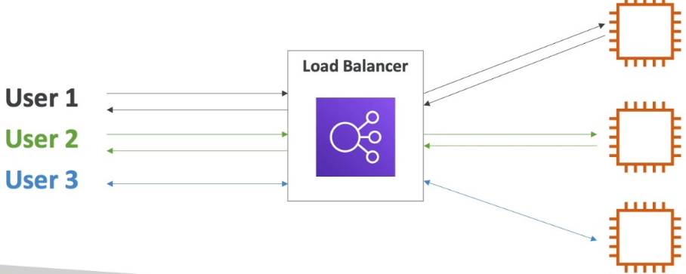

Why to use a load balancer?

* To spread the load across multiple downstream EC2 instances
* To expose our single point of access (DNS hostname) to your application
* Do a regular health check of our EC2 instance and if one EC2 instance is failing then we can hide it i.e., Load Balancer will not route load to that EC2 Instance.
* Provide SSL termination (HTTPS encryption and decryption process) for your website

Why use an Elastic Load Balancer (ELB)?

* An ELB is a managed load balancer so you don’t need to provision servers AWS will do it for you
  + AWS will guarantee that it will be working
  + AWS will take care of all its upgrades, maintenance, high availability of that ELB
  + All we need to do is configure some behavior of that Load Balancer
* It actually costs less to set up your own load balancer, but maintenance cost will be high
* Three kinds of load balancer provided by AWS – (only high-level understanding is required)
  + Application Load Balancer (HTTP/HTTPS only) – is used for load balancing HTTP and HTTPS traffic. Application Load Balancer operate at Layer7 of the OSI model and so they are application aware. As Application Load Balancer is HTTP aware, they support advanced request routing to specific web servers based on the HTTP header.
    - OSI Model is also called a 7 Layer model,

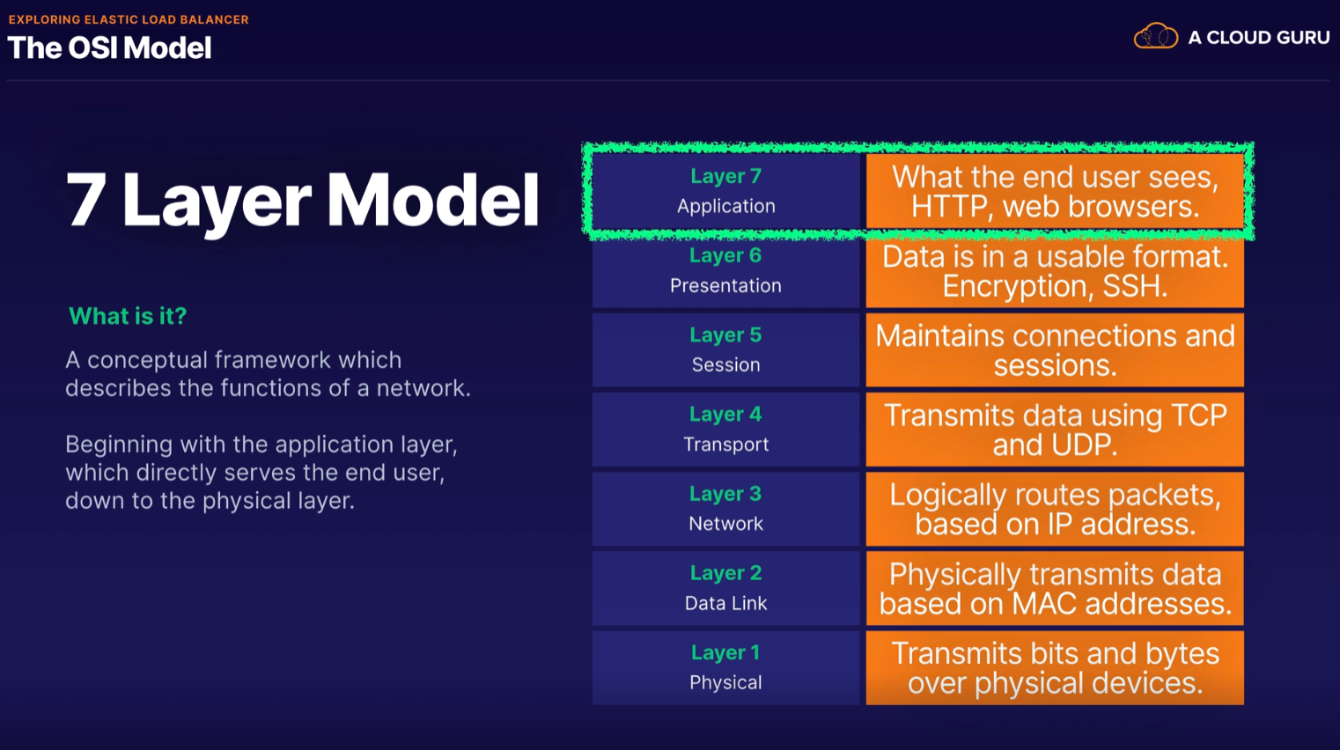

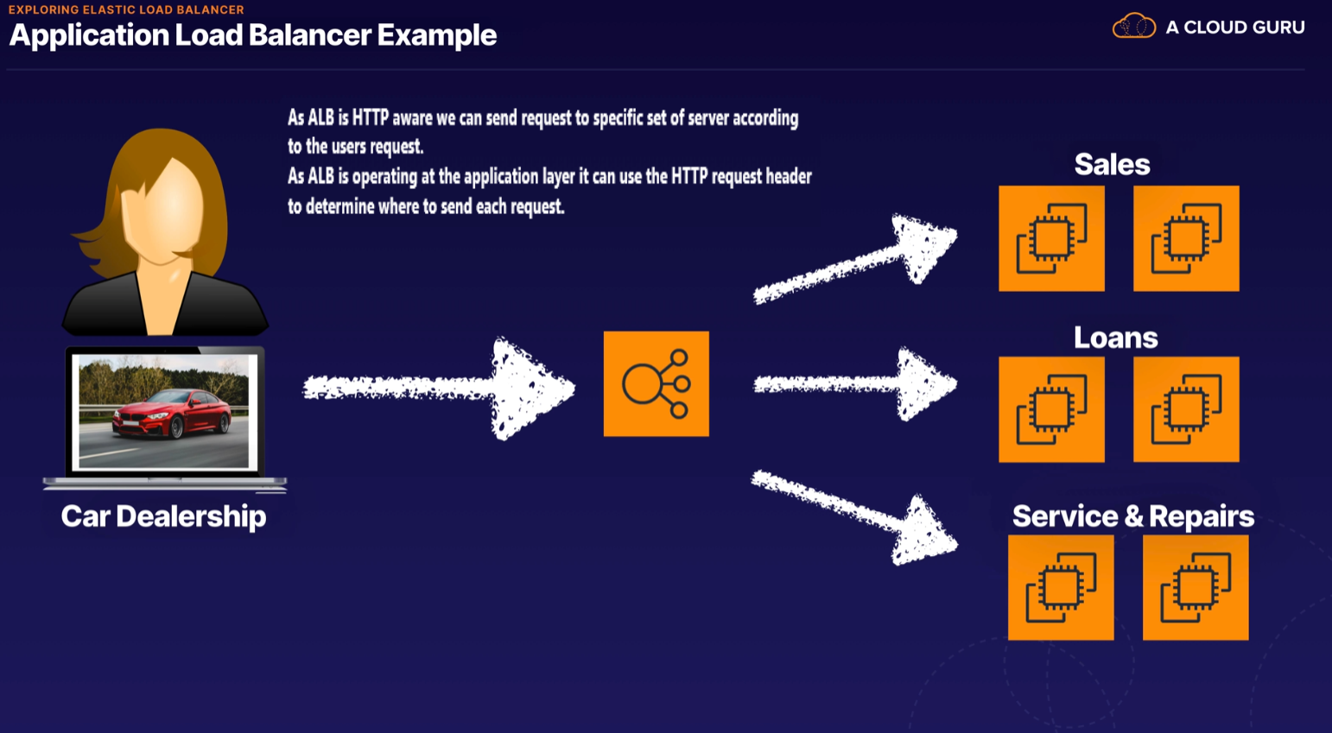

* + Network Load Balancer - ultra-high performance, can handle millions of requests per second, used for Load Balancing TCP traffic and it operates at Layer 4 of the OSI Model. It is the most expensive option.

Q: You work for a media production company that streams popular TV shows to millions of users. They are migrating their web application from an in house solution to AWS. They will have a fleet of over 10,000 web servers to meet the demand and will need a reliable layer 4 load balancing solution capable of handling millions of requests per second. What AWS load balancing solution would best suit their needs?

A: Network Load Balancer is best suited for load balancing of Transmission Control Protocol (TCP), User Datagram Protocol (UDP) and Transport Layer Security (TLS) traffic where extreme performance is required. Operating at the connection level (Layer 4), Network Load Balancer routes traffic to targets within Amazon Virtual Private Cloud (Amazon VPC) and is capable of handling millions of requests per second while maintaining ultra-low latencies.

* + Gateway Load Balancer
  + Classic Load Balancer (slowly retiring) – supports some Layer 7 specific feature like X-Forwarded-For and some Layer 4 feature.

X-Forwarded-For – it is a HTTP Header which stores the IP of the user’s machine from where the request is sent.  Your access logs capture the IP address of your load balancer because the load balancer establishes the connection to your instances. You must perform additional configuration to capture the IP addresses of clients in your access logs. For Application Load Balancers and Classic Load Balancers with HTTP/HTTPS listeners, you must use [X-Forwarded-For](https://docs.aws.amazon.com/elasticloadbalancing/latest/userguide/how-elastic-load-balancing-works.html#http-headers) headers to capture client IP addresses. Then, you must print those client IP addresses in your access logs.

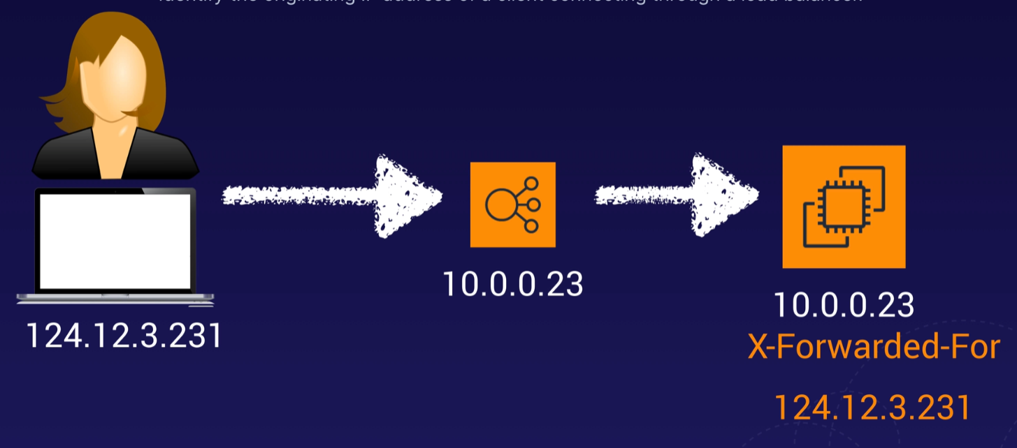

What is an Auto Scaling Group?

* In real life, load in your websites and applications can change overtime. We know that in cloud, you can create and get rid of servers very quickly. So, the goal of our Auto Scaling Group (ASG) is to –
  + Scale Out (add EC2 Instances) to match and increased load
  + Scale In (remove EC2 Instances) to match a decreased load
  + We can also ensure that we have a min & max number of machines running all the time
  + And whatever is done by ASG i.e., add or remove instances it is automatically registered by the Load Balancer
  + Also, it can replace unhealthy instances
* Using ASG the Cost Saving is huge because we are running at an optimal capacity

Auto Scaling Groups – Scaling Strategies:

* Manual Scaling: When we update the size of our ASG manually
* Dynamic scaling: to respond to changing demands automatically
  + Simple/Step scaling – we define a trigger, and we define how many instance to add based on that trigger. The trigger triggers a CloudWatch alarm
  + Target Tracking Scaling – where we define a target and ASG adds or removes instance to stay on that target. Target example – average ASG CPU to stay around 40%
  + Schedule Scaling – when we know when the changes are going to happen ahead of time and anticipate scaling based on known usage patterns. E.g. - on weekends there will be more load on the server so increase instances on weekends
  + Predictive Scaling – Uses machine learning to predict future traffic ahead of time. This uses past patterns to predict the scaling

**Route 53**:

* Amazon’s DNS Service is called Route 53. It allows you to map a domain name that you own to EC2 Instances, Load Balancers and S3 Buckets.
* DNS (Domain Name System) is the process computers use to resolve domain names to IP Addresses.
* It is a Global service
* Failover Routing and Latency-based Routing are the only two correct options, as they consider routing data based on whether the resource is healthy or whether one set of resources is more performant than another. Any answer containing location based routing (Geoproximity and Geolocation) cannot be correct in this case, as these types only consider where the client or resources are located before routing the data. They do not take into account whether a resource is online or slow. Simple Routing can also be discounted as it does not take into account the state of the resources.

**AWS Databases:**

**AWS Relational Database Service (RDS)** –

* It is a managed database service for databases that uses SQL as it’s query language
* It allows you to create databases in the cloud that are managed by AWS
* Databases types –
  + Postgres
  + MySQL
  + MariaDB
  + Oracle
  + Microsoft SQL Server
  + Aurora (AWS Proprietary database)

Advantages of using RDS vs deploying DB on EC2:

* RDS is a managed service i.e.
  + Provisioning the database and OS patching will be automatic and done by AWS
  + Continuous backups and restore to specific timestamp
  + Monitoring dashboards to see if our databases are doing good
  + *Read Replicas for improved read performance - Read replicas are read-only copies of production database and we set up our EC2 instances to read from the Read Replicas and not from PROD DB so it doesn’t have a performance hit. We can also have multiple (up to 5) read replicas for the same DB and in same or different AZ to improve the performance even more.
    - Must have Automatic Backup turned on for read replica
    - Read replica can be promoted to a master DB (done for Disaster Recovery)
  + *Multi-AZ for Disaster recovery (high availability) – Multi-AZ allows you to have an exact copy of your PROD DB in another AZ (AWS handled the replication for you), if one AZ fails the RDS will start pointing (failover in case of issues with main DB) to the other AZ automatically. Data transferred between Availability Zones for replication of Multi-AZ deployments is free.
  + Scaling Capability (both Vertical and Horizontal)
* But we cannot SSH into our RDS DB instance. Patching of RDS is responsibility of Amazon.
* RDS is not Serverless

Under what circumstances would I choose provisioned IOPS over standard storage when creating an RDS instance?

🡪If you need to run an I/O- intensive relational DB for a mission-critical application in PROD. Provisioned IOPS becomes important when you are running production environments requiring rapid responses, such as those which run e-commerce websites. Without high performant responses from an RDS instance page loads of the website could suffer resulting in loss of business. If your workloads are not latency sensitive or you are running a test environment the additional cost of provisioned IOPS will not be cost beneficial to your project.

Two types of backup for RDS:

* Automated Backup
  + Automated backups take a full daily snapshot and will also store transaction logs throughout the day this allows you to do a point in time recovery down to a second, withing the retention period (1-35 days)
  + When you do a recovery, AWS will first choose the most recent daily backup and then apply transaction logs relevant to that day, up to the recovery point.
  + It is enabled by default and the backup is stored in S3.
  + You get free storage space equal to the size of your database. So if you have an RDS instance of 10GB, you will get 10GB worth of storage.
  + Backup will be only taken during the Backup Window that we define. During the backup window, storage I/O may be suspended for a few seconds while the backup process initializes, and you may experience increased latency at this time.
* Database Snapshot
  + Backup Snapshots are done manually
  + The Snapshots are stored even after the RDS instance is deleted unlike Automated backup
  + I/O may be briefly suspended while the backup process initializes (typically under a few seconds), and you may experience a brief period of elevated latency.

*When restoring the backup from either Automated backup or DB Snapshot the restored DB will be a new RDS instance with a new DNS endpoint.

RDS Solution Architecture:

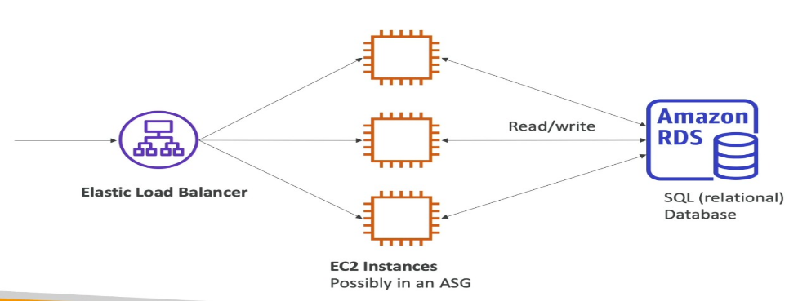

**Amazon Aurora**:

* It is a database technology created by Amazon (not open sourced), it is same as RDS i.e., EC2 instance connect directly to Aurora
* PostgreSQL & MySQL are both supported by Aurora DB
* Aurora is AWS Cloud Optimized and will give performance improvement over RDS and the storage will grow automatically (starts with 10GB, and then scale in 10GB increments up to 64GB automatically)
* Cost is more than RDS
* When an Aurora DB is created 2 copies of your data is contained in a minimum no of 3 AZ (no. of AZ can be increased) giving you 6 copies of your data
* Aurora Serverless DB is an on-demand auto-scaling DB which starts up, shut down and scales capacity up or down based on your application’s needs. This is useful for applications with infrequent, intermittent, or unpredictable workloads.
* From RDS instance we can create Aurora read replicas, which then can be promoted to a master DB. (RDS to Aurora migration)
* Aurora Snapshots can be shared across AWS Accounts.

**Amazon ElastiCache**:

It is a web service that makes it easy to deploy, operate and scale an in-memory cache in the cloud. The service improves the performance of the web application by allowing you to retrieve information from fast, managed, in memory cache instead of relying entirely on slower disk-based databases

Cashes are in-memory databases with high performance and low latency. ElastiCache cashed the most common queries inside its servers and returns them a lot faster than what a database would do. It is a way of caching your most common queries and returning the results when required and it takes a massive load off your primary database.

ElastiCache is a good choice if your database is particularly read-heavy and not prone to frequent changing. If data is changing too frequently then ElastiCache will struggle to have the latest data available.

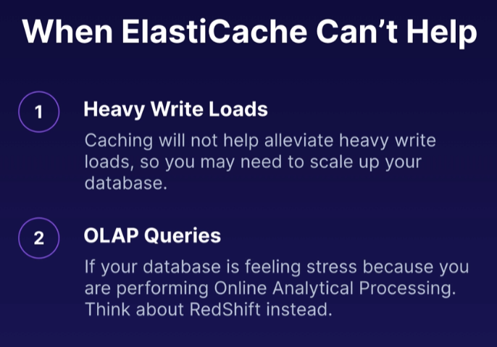

ElastiCache supports two open-source in-memory caching engines:

* Memcached - Great for basic object caching. Scales horizontally, but there is no persistence, Multi-AZ or failover. A good choice if you just want basic caching and you want your caching model to be as simple as possible.
* Redis (Multi-AZ and we can do backups and restore of Redis)

**AWS NoSQL Database**:

DynamoDB –

* It is not a relational database it is a fully managed NoSQL database.
* With RDS or ElastiCache we need to provision a server but for DynamoDB we don’t need to i.e., it is serverless
* Scales to massive workloads, millions of records per second
* Fast and consistence performance – Single-digit millisecond latency retrieval
* Stored on SSD, which gives consistent fast performance for reads and writes
* The underlying hardware supporting DynamoDB is always spread across 3 geographically distinct data centers.
* The maximum item size in DynamoDB is 400 KB
* It has 2 different types of read model –
  + Eventual Consistent Reads (default) – Consistency across all copies of data across all 3 data centers is usually reached within 1 second. Best for Read performance.
  + Strongly Consistent Reads – All successful writes are reflected across all 3 locations at once. if data must be read within or less than 1 second of writing it. Best for Read Consistency.

DynamoDB Transactions provide the ability to perform ACID Transactions (Atomic, Consistent, Isolated, Durable).

ProvisionedThroughputExceededException error means the number of requests is too high.

Each AWS SDK implements an Exponential Backoff algorithm for better flow control. The idea behind exponential backoff is to use progressively longer waits between retries for consecutive error responses.

* DynamoDB is a key/value database ([https://aws.amazon.com/nosql/key-value](https://aws.amazon.com/nosql/key-value/)/)  
  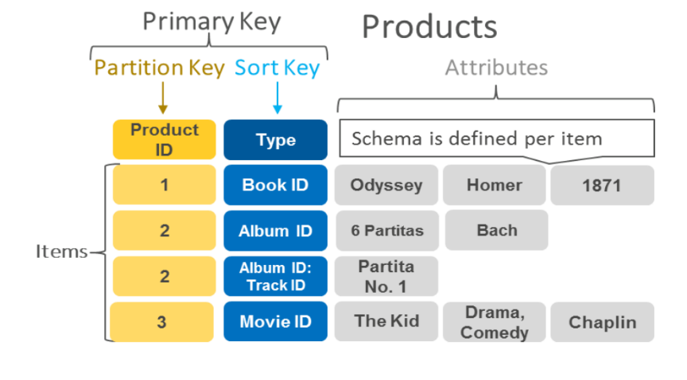
* Amazon DynamoDB supports GET/PUT operations by using a user-defined primary key. The primary key is the only required attribute for items in a table. You specify the primary key when you create a table, and it uniquely identifies each item. DynamoDB also provides flexible querying by letting you query on nonprimary key attributes using global secondary indexes and local secondary indexes.
* In-memory cache for DynamoDB – DynamoDB Accelerator (DAX)

DynamoDB Primary key:

DynamoDB stores and retrieves data based on a primary key.

Two types of primary key –

* Partition Key - it is a unique attribute. Value of the partition key is input to an internal hash function within DynamoDB which determines the partition or physical location on which the data is stored. If you are using the partition key as your primary key, then no two items can have the same partition key.
* Composite Key – when Partition key is not necessarily unique we use Composite key (Partition key + Sort Key).

We can configure fine-grained access control on DynamoDB using IAM,  
IAM condition parameter dynamodb: LeadingKeys allows users to access only the items where the partition key value matches their User_ID. The user will able to view only those data in DynamoDB where userId value matches user’s userid and no other data.

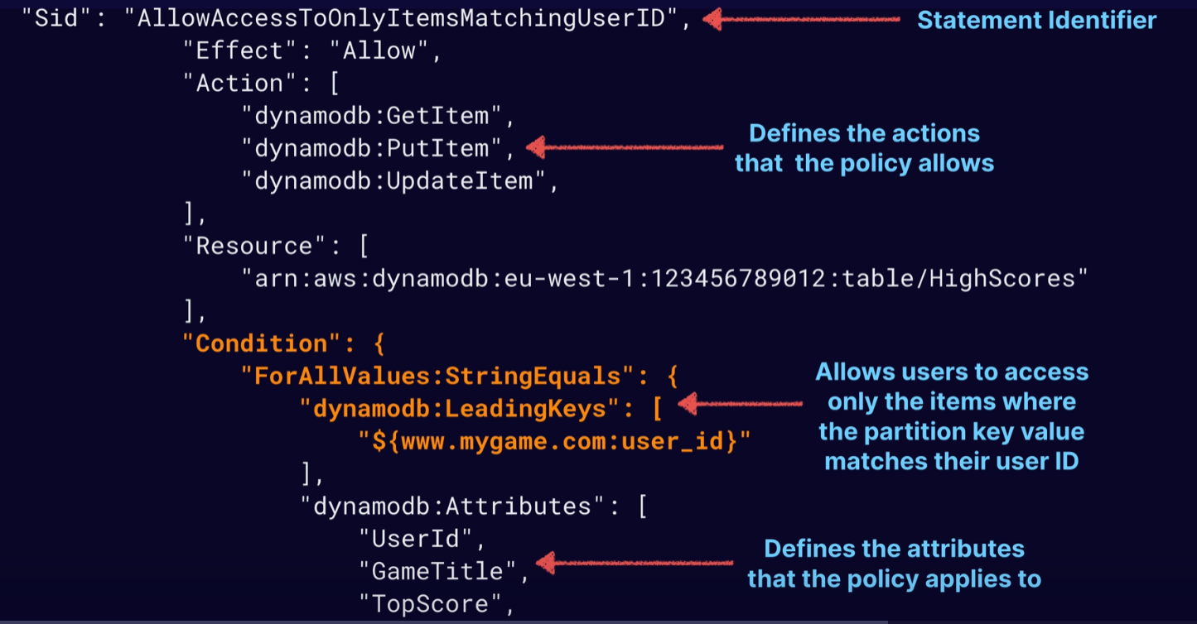

Secondary Index in DynamoDB:

Secondary index allows you to perform more flexible query within DynamoDB. It allows you to query based on an attribute which is not the Primary key.   
DynamoDB allows you to run a query on non-primary key attributes using Global Secondary indexes and Local Secondary indexes.

A secondary index allows you to perform fast queries on specific columns in a table. You select the columns that you want included in the index and run your searches on the index, rather than on the entire dataset.

**Local Secondary Index allows you to use any sort key but partition key should be same as original table whereas in Global Secondary indexes we can choose any partition key and sort key of our choice.

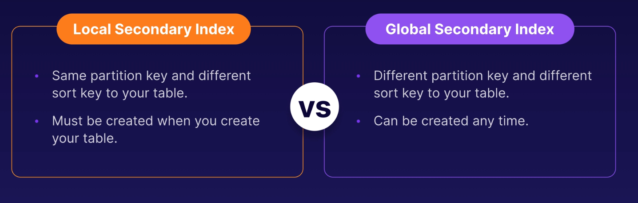

There is an initial quota of 20 global secondary indexes per table. We can request a service quota increase by raising a ticket to AWS support.

DynamoDB Scan vs Query:

A query finds items in a table based on the primary key attribute and a distinct value to search for. By default, a query returns all the attributes for the items you select, but you can use the Projection Expression parameter if you want to only return the specific attributes you want. The results are always sorted by the sort key, you can reverse the order by setting the ScanIndexForward parameter to false.

A scan operation examines every item in the table. By default, it returns all data attributes. You can use the Projection Expression parameter here also.

The Impact of a Query or Scan can be reduced by setting a smaller page size which uses fewer read operations

Avoid Scan operations if you can.

Improve Scan performance - Try parallel scans rather than the default sequential scan.

Isolate scan operations to specific tables and segregate them from your mission-critical traffic.

Reduce the page size to return fewer items per results page.

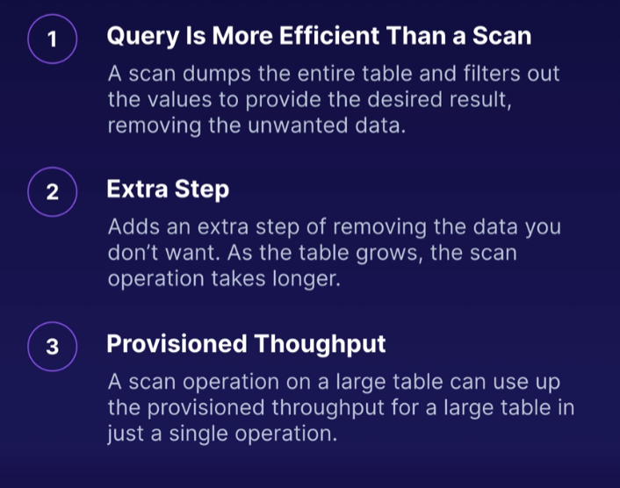

DynamoDB CLI Commands:

* Know how to use each of the common commands listed in this lesson.
* The CLI commands are making calls to a DynamoDB API.
* The correct IAM permissions are required to make an API call.

CLI commands in white, API calls in orange,

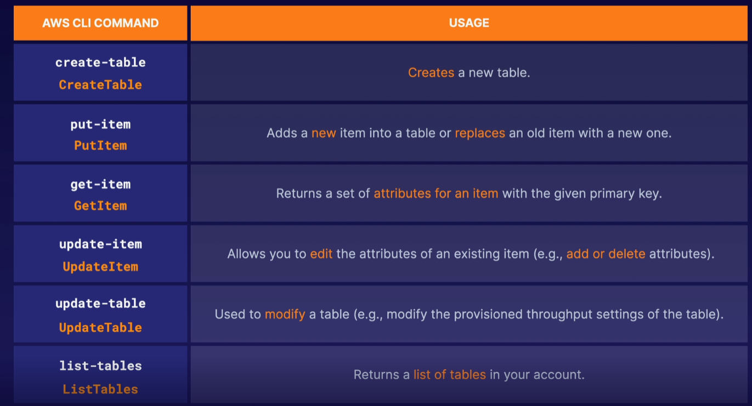

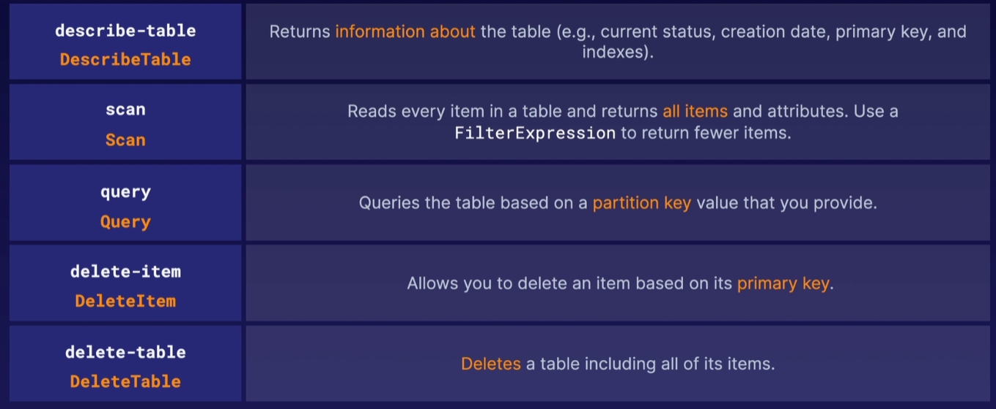

The BatchGetItem operation returns the attributes of one or more items from one or more tables.

**DynamoDB Provisioned Throughput**:

DynamoDB Provisioned Throughput is measured in Capacity Units. When you create your table, you can specify your requirements in terms of Read Capacity units and Write Capacity units and it is this read and write capacity units which defined how much data you can read or write in your DynamoDB table.

Write Capacity Units – for each Write capacity units you get 1KB write per second i.e., 1 x write capacity unit = 1KB write per second.

Read Capacity Units – for each Read Capacity Units you get 4KB strongly consistent read per second OR 2x eventually consistent reads of 4KB per second i.e.,

1 x read capacity unit = 1 x strongly consistent read of 4KB per second.

OR

2 x eventually consistent reads of 4KB per second (default).

Provisioned throughput limits can be increased by raising a ticket to AWS support.

**DynamoDB Pricing Model:**

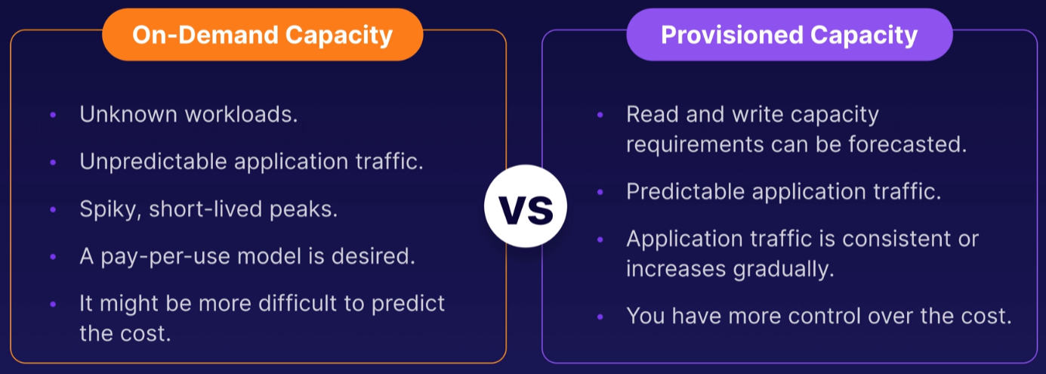

DynamoDB Accelerator (DAX) - DynamoDB Accelerator (or DAX) is a fully managed, clustered in-memory cache for DynamoDB. It gives you a massive performance improvement for your DynamoDB tables but only for read performance i.e., it can deliver up to a 10x read performance improvement.

DAX is a write-through caching service. Anytime the DynamoDB table gets updated the DAX is updated as well. This allows you to point your DynamoDB API calls at the DAX cluster i.e., instead your application query DynamoDB it will query the DAX cluster first. If the item you are querying is in the cache (cache hit), DAX returns the result.

DAX is not suitable for,

* applications that require strongly consistent reads or applications which are mainly write-intensive.
* Applications that do not require microsecond response times.

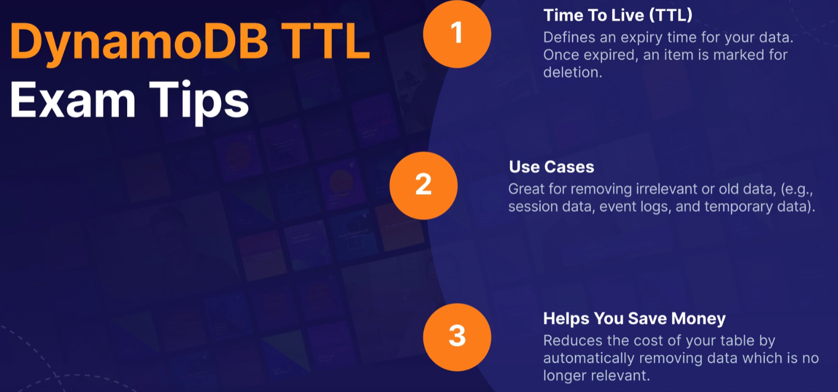

**DynamoDB Streams:**

It is a Time Ordered Sequence or Stream and records modifications of items in your DynamoDB table i.e., anytime there is an insert, update, delete operation its going to record that in a log and logs are encrypted at rest and stored for 24 hours only.

Use -

* Used for audit purposes as it logs changes in real-time
* Mainly used for triggering events whenever there is a change in DB like triggering a lambda function or your application to do something.

DynamoDB streams are access using their dedicated endpoint.  
By default only the primary key of the row which is updated is recorded.  
State of item before and after it is modified can be captured.

Redshift Database (Amazon's data warehousing solution):

* OLTP is Online Transaction Processing it is done by RDS. Redshift is used for OLAP i.e., Online Analytical Processing (analytics and data warehousing)

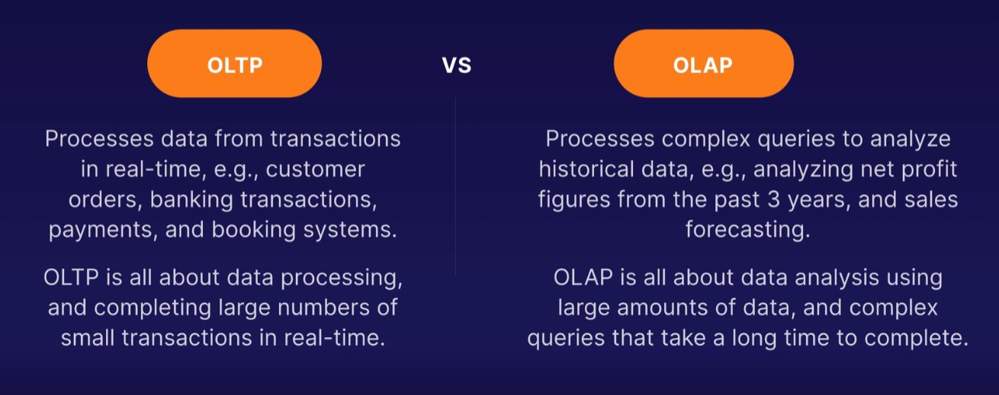

* Redshift is good at analyzing data and making some computations from it (used for business analytics). It has 10x better performance than other data warehouses.
* Columnar storage of data (instead of row based) and Massively Parallel Query Execution (MPP)
* In OLAP complex queries are run that can have a performance hit on our PROD DB, that is why Data Warehousing is used to do these analytics away from prod DB
* It is currently available in only one AZ (not Multi-AZ)
* Backup is enabled by default with 1-35 days retention process

Amazon EMR (Elastic MapReduce):

* EMR stands for Elastic MapReduce.
* It is not a DB, it is used to create a Hadoop Cluster (Big Data) to analyze and process vast amount of data.
* It is used for big data processing
* The central component of Amazon EMR is a cluster. A cluster is a collection of Amazon EC2 instances. Each instance in the cluster is called a node. Each node has a role within the cluster, referred to as the node type.
* The node type consists of a master node or core node and the task node (optional)
* by default, logs are stored on the master node
* you can configure replication to S3 on five minutes intervals for all log data from the master node, however, this can only be configured when creating that cluster for the first time

Athena:

It is a fully Serverless database with SQL capabilities and is used to query data in S3. The o/p of the query is put back in Amazon S3. Pay per use.  
Use Case: to do one-time serverless queries on S3 and log analytics.

DocumentDB:

Same as Aurora as an AWS implementation of PostgreSQL/MySQL, DocumentDB is the AWS implementation of MongoDB (NoSQL DB)

Amazon Neptune:

AWS managed Fully managed graph database.

Amazon QLDB:

QLDB stands for Quantum Ledger Database. It is used to review history of all the changes made to your application data over time. It is an Immutable System i.e., no entry can be removed or modified.

**Amazon DMS** – Database Migration Service:

* It is a cloud service used to migrate relational DB, data warehouses, NoSQL DB etc. You can migrate it on the cloud, off the cloud etc.
* It is used to migrate data from one DB to another DB. To migrate the data, we need to run the DMS in an EC2 instance which will extract the data from the source DB and insert the data back to target DB. The Source DB does not go down while running DMS
* DMS supports both homogeneous (Oracle 🡪 Oracle) and heterogenous migrations (Oracle 🡪 Aurora)
* For heterogenous migrations AWS Scheme Conversion Tool (SCT) is required.
* Source database remains fully operational during the migration, minimizing downtime to applications that rely on the database.

Amazon Glue:

It is a Managed extract, transform and load service (ETL). It is a serverless service useful to prepare and transform data for analytics i.e., for Redshift.

Elastic Beanstalk – with Elastic Beanstalk, you can quickly deploy and manage applications in the AWS Cloud without worrying about the infrastructure that runs those applications i.e., EC2 instances, S3 buckets etc.  
We simply need to upload our application and Elastic Beanstalk automatically handles the details of the capacity provisioning, load balancing, scaling and application health monitoring. It is a PaaS.

**AWS Security**:

AWS Compliance & Artifact deals with documentation of various compliance.

**AWS Shared Responsibility Model**:

While AWS maintains the Security of the Cloud, Security in the Cloud is the responsibility of the customer. have customers retain control of what security did choose to implement to protect their own content, platform, applications, system and networks have no different than they would in an on-site data center.

<https://aws.amazon.com/compliance/shared-responsibility-model/>

**AWS WAF** – WAF stands for Web Application Firewall, it helps protect web application from common web exploitation that could affect application availability, compromise security or consume excessive resources. WAF can inspect your web traffic and detect if someone is doing malicious things like SQL injection, Cross Site Scripting etc. It operates at Level 7 i.e., Application layer and prevents attacks from reaching to our application

**AWS Shield** - AWS Shield is a managed (AWS managed) Distributed Denial of Service (DDoS) protection service that safeguards web application running on AWS.   
DDoS attack is simply when someone maliciously sends a lot of traffic to your application server that your web server stops responding.  
There are two tires of AWS Shield – Standard and Advanced.

AWS WAF Is a web application firewall, designed to stop hackers whereas AWS Shield is DDoS mitigation service designed to stop DDoS attacks.

**Amazon Inspector**:

Amazon inspector is an automated security assessment service that helps improve the security and compliance of applications deployed on AWS (installed on EC2 and do assessments on EC2). It automatically assesses application for vulnerabilities or deviation from best practice and produces a detailed list of security findings.

It is installed on an EC2 instance and look for common vulnerabilities

**AWS Trusted Advisor**:

It is an online resource to help you reduce cost, increase performance and improve security by optimizing your AWS environment. Advisor will advise you on Cost Optimization, Performance, Security, Fault Tolerance and Service Limits. It looks at your entire AWS Account not just your EC2 instance

* Core Checks and Recommendations – free
* Full Trusted Advisor – for Big Orgs

**AWS Cloud Trail**:

It increases visibility into your AWS Environment by recording AWS Management Console actions and API calls (so if someone goes in and creates a user or a group or a role or EC2 instance etc. AWS Cloud Trail will recode that). You can identify which users and account called AWS, the source IP address from which the calls were made and when the calls occurred (it is all saved in S3).

**CloudWatch**:

Amazon CloudWatch Is a monitoring service to monitor your AWS resources, as well as the application that you would run on AWS. It monitors performance of AWS resource.

* Cloud watch with EC2 monitors events every five minutes but with detailed monitoring on it monitors every one minute
* You can create cloud watch alarms to trigger notifications.

**AWS Config**:

AWS Config monitors the config/settings of your AWS environment. Any changes made to any settings is recorded (e.g., if we change the configuration of our security group and open port 80 to the internet) and shown to you.  
AWS Config Provides a detailed view of the configuration of AWS resources in your AWS account. With AWS Config you can see how the configurations and relationships between resources have changed overtime.

**Penetration Testing**:

Also known as pen test, it is a simulated cyber attack to test your system and check for exploitation and vulnerabilities.

Pen test can be carried out on 8 different services (without approval) –

* EC2, Elastic Load Balancer (ELB), NAT Gateway
* Amazon RDS
* Amazon CloudFront
* Aurora
* Amazon API Gateway
* Lambda & Lambda Edge functions
* Amazon Lightsail Resources
* Amazon Elastic Beanstalk Environment

For other services we need to contact Amazon.

**VPC (Virtual Private Cloud)**:

What is VPC and benefits? 🡪 <https://aws.amazon.com/vpc/?vpc-blogs.sort-by=item.additionalFields.createdDate&vpc-blogs.sort-order=desc>

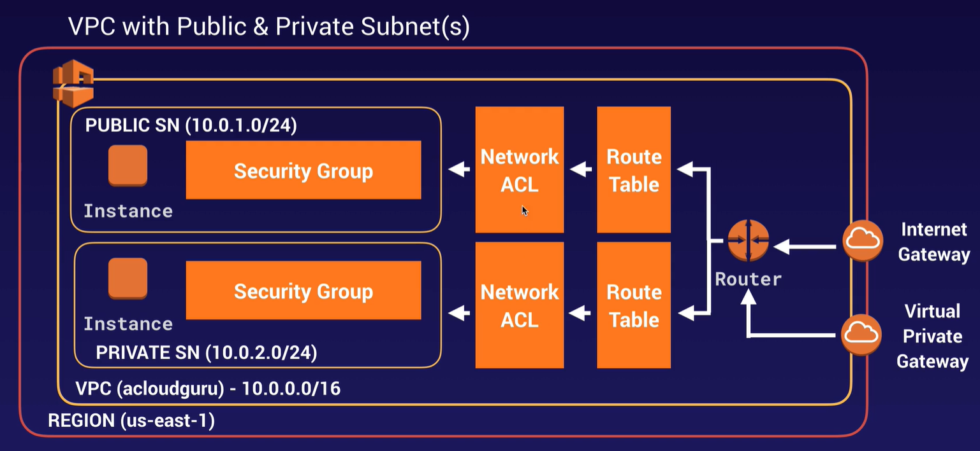

* When you create a VPC a default Route table, Network Access control (Network ACL) and a default Security Group is created
* It will not create any subnet, nor will it create a default internet gateway
* You can have only one Internet Gateway per VPC
* While creating VPC you basically choose the range of IP Addresses i.e., you define the staring IP address  
  If your define starting IP Address as 10.0.0.0/26, this means -  
  Starting IP 🡪 10.0.0.0  
  End IP 🡪 10.0.0.63   
  calculation 🡪 { 2^(32-26) = 2^6 = 64}  
  between this range you can use any IP address

Creating Subnet for a VPC:

* While creating a subnet you are basically diving the IP addresses allocated by VPC, for the above VPC we can create the following subnets with the following IP address range  
  subnet1 🡪 start: 10.0.0.0/28 | end: 10.0.0.15/28   
  subnet2 🡪 start: 10.0.0.16/28 | end: 10.0.0.31/28  
  subnet3 🡪 start: 10.0.0.32/28 | end: 10.0.0.47/28  
  subnet4 🡪 start: 10.0.0.48/28 | end: 10.0.0.63/28  
  calculation 🡪 { 2^(32-28) = 2^4 = 16} each subnet has 16 IP addresses
* While we can see each subnet should have 16 Available IP Addresses but in AWS console, we will get only 11 Available IP Addresses. The reason for that is for each subnet AWS reserves 5 IP Addresses (first 4 and the last IP Address)
* In the public subnets the ‘Enable auto assign public IP address’ should be true. When instance launched in this subnet should get a public IP.

Associating the subnets with Route Table:

* Each subnet should be associated to a Route Table. If the subnets are not associate to any route table, it will automatically use the Main route table which is automatically create for that VPC
* A subnet is considered Public only when there is a route available in the associated Route table to the Internet Gateways. Internet Gateway (is a managed service) allows connection of your VPC to outside internet. Only one Internet Gateway can be attached to a VPC

All the private instance like DB needs to connect to the internet for patching, updates etc. for this the private Route Tables are attached to the NAT Gateway. The NAT Gateway is a managed service which can be attached to a public subnet and the private instance through the private route tables connect to the internet through NAT Gateway, it acts as a forward proxy.

**AWS Billing & Pricing**:

The basic pricing policies are as follows –

* Pay as you go – pay as in when you need the resource
* Pay less when you reserve – the more the contact term the more the discount
* Pay less per unit by using more AWS service
* Pay even less as AWS grows
* Custom pricing

Understanding the Fundamentals of Pricing –

* Compute
* Storage
* And Data Outbound – data leaving your AWS environment not entering in

AWS offers pricing models depending on the product, these includes –

* On Demand
* Dedicated Instances
* Spot Instances
* Reservations

Free services in AWS –

* Amazon VPC
* Elastic Beanstalk
* CloudFormation
* Identity Access Management (IAM)
* Auto Scaling (auto scaling is free but the allocated EC2 Instances will have its cost)
* Opsworks
* Consolidated Billing

EC2 pricing is dependent on –

* Clock hour of Server time
* Instance type
* Pricing model (on-demand, reserved etc.)
* No of Instances
* Type of Load Balancing used (Network LB costs more than Classic LB)
* Detailed monitoring
* EC2 Instances allocated by Auto Scaling
* Different AMI

Lambda pricing is dependent on –

* Request pricing – no of request end to our lambda instance
  + Free tier: 1 million requests per month
  + $0.20 per 1 mission requests thereafter
* Duration pricing – how long your lambda functions are executing for

EBS pricing is dependent on –

* Volumes (priced per GB data stored)
* Snapshots (per GB)
* Data Transfer

S3 pricing is dependent on –

* Storage Class
* Storage
* Requests (get, put, copy)
* Data Transfer

RDS pricing is dependent on –

* Clock hours of server time
* Database characteristics (MySQL or Arora etc.)
* Database Purchase Type – how large the DB is
* No of DB instances
* Provisioned Storage (no of GBs allocated)
* Additional Storage
* Requests
* Deployment Types
* Data Transfer

AWS Budgets:

Gives you the ability to set custom budgets that will alert you when the cost exceeds your budget. Is used Before the cost is incurred

AWS Cost Explorer:

It lets you visualize, understand, and manage your AWS Cost and usage After cost have incurred.

Tags – tags are key value pairs attached to AWS resource | shows Metadata | Tags can sometimes be inherited

Resource Groups – it makes it easy to group your resources using the tags that are assigned to resources. Using Resource Grouping you can apply automation to the resources tagged. E.g. – stop all EC2 instances in a particular tagged region.

**AWS Organizations**:

* Comes in 2 types –
  + AWS Organization full access – we create Organizational units (OU) and we put AWS Accounts behind those units, and we can apply policy either to the OU or the AWS Account itself
    - The Root Account should be used for billing purpose only
    - CloudTrail (audits activity) works per AWS Account and is enabled per region. Should be set up so that the audit logs can be sent to S3 bucket in the Root Account
  + AWS Organizations with consolidated billing – allows you to get volume discounts on all your accounts

AWS Quick Start – it is a way of deploying environments quickly using CloudFormation templates built by AWS Solutions Architects who are experts in that technology.

AWS Landing Zone is a solution that helps customers more quickly set up a secure, multi-account AWS environment based on AWS best practices.

Different Calculators in AWS -

AWS Simple Monthly Calculator is used to calculate your running costs on AWS on a per month basis. It is not a comparison tool.

AWS Total Cost of Ownership (TCO) calculator is used to Compare cost of running your infrastructure on premise versus in the AWS cloud. It will generate reports that you can give to your management to make a business case to move to the cloud.

The five pillars of AWS:

* Operations Excellence – its about whatever you built continuous to work and works well with least amount of effort
* Cost Optimization – spending the optimal amount
* Reliability – the system we build if it will work consistently and recover quickly
* Performance Efficiency – remove bottlenecks, reduce waste
* Security -

**AWS CloudFront**

CloudFront is a content delivery network (CDN). It uses Edge locations to deliver content/data to the users. Requests for your content are automatically routed to the nearest Edge location so as to get the best performance.   
Edge location is the location where the content is cashed. This is different from an AWS Region/AZ  
A CloudFront distribution is a link between an origin server (such as an Amazon S3 bucket) and a registered domain name (such as Amazon Route 53 or a different registrar). Through this link, CloudFront identifies the object you have stored in your origin server.

Using CloudFront,

* requests for your content are automatically routed to the nearest edge location, so content is delivered with the best possible performance.
* Allows you to optimize performance for users accessing your website from all around the world.
* CloudFront Edge Locations are utilized by S3 Transfer Acceleration to reduce latency for S3 uploads.

CloudFront Allowed Methods –

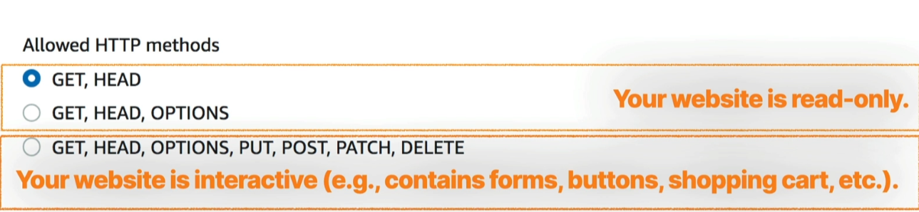

Q: Which of the following options allows users to have secure access to private files located in S3?

* CloudFront Signed URLs
* CloudFront Origin Access Identity
* CloudFront Signed Cookies

There are three options in the question which can be used to secure access to files stored in S3 and therefore can be considered correct. Signed URLs and Signed Cookies are different ways to ensure that users attempting access to files in an S3 bucket can be authorized. One method generates URLs and the other generates special cookies but they both require the creation of an application and policy to generate and control these items. An Origin Access Identity on the other hand, is a virtual user identity that is used to give the CloudFront distribution permission to fetch a private object from an S3 bucket. Public S3 buckets should never be used unless you are using the bucket to host a public website and therefore this is an incorrect option.

AWS Lightsail - Amazon Lightsail is a Platform as a Service (PaaS) to host websites and web applications. Platforms as a service remove the need for organizations to manage the underlying infrastructure (usually hardware and operating systems) and allow you to focus on the deployment and management of your applications. This helps you be more efficient as you don’t need to worry about resource procurement, capacity planning, software maintenance, patching, or any of the other undifferentiated heavy lifting involved in running your application.

**Parameter Store** –

* This AWS Service is used to store confidential information, so you can store things like password, DB connection strings, software license keys etc. i.e. any piece of data that is useful for our application which you want to store centrally in a secured way.
* Values can be stored in a plain text or in a secured/encrypted way using KMS
* You can reference your parameters using the parameter name, e.g., in a bootstrap script.
* You can use Parameter Store with EC2, CloudFormation, Lambda, CodeBuild, CodePipeline and CodeDeploy.

**Serverless:**

Serverless allows you to run your application code in the cloud without having to worry about managing any servers. AWS handles the infrastructure management tasks so that you can focus on writing code. AWS takes care of Capacity, Provisioning, Patching, Auto Scaling and High Availability. Serverless applications are event-driven and you are only charged when your code is executed, so cost is low.

Serverless Technologies example,  
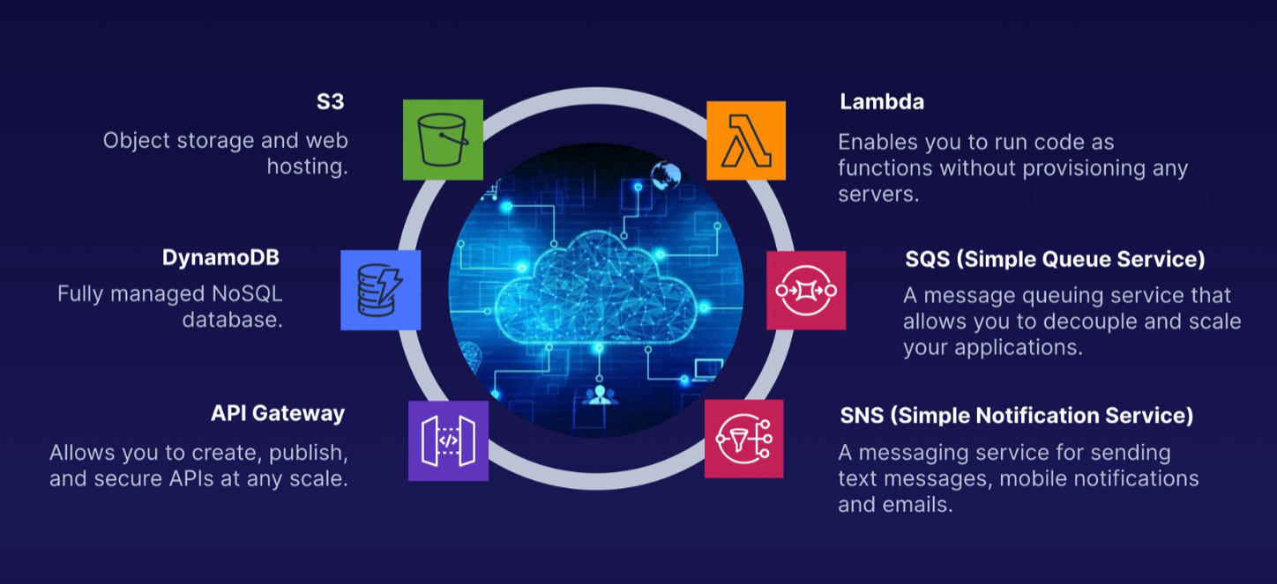

**AWS Lambda**:

Lambda is serverless compute. It allows you to run your code in AWS without provisioning any servers. Lambda takes care of everything required to run your code, including the runtime environment.

Supported Languages are - Java, Go, PowerShell, Node.js, C#, Python, and Ruby.  
All you need to do is upload your code to Lambda and you are good to go. Enterprise features like Auto-Scaling and High Availability are already baked in to the Lambda service.

Lambda Pricing - You are charged based the number of requests, their duration, and the amount of memory used by your Lambda function.

* AWS Lambda are Virtual Functions, we don’t need to manage any servers.
* They are intended for shorter type of execution.
* It will run On-Demand
* Scaling is automated i.e., if the no. of request increases, then Lambda functions will scale itself according to that
* We can run the function using programming language

Benefits –

* Pay per request/call & per duration i.e., compute time. Extremely cost effective
* Integrated with many other AWS Services
* It is Event Driven i.e.; functions get invoked by AWS when needed.
* Lambda scales automatically.

Lambda Versions

When you create a Lambda function, there is only one version: $LATEST

• When you upload a new version of the code to Lambda, this version will become $LATEST

• You can create multiple versions of your function code and use aliases to reference the

version you want to use as part of the ARN

* Example - In a development environment you might want to maintain a few versions of the same

function as you develop and test your code

• An alias is like a pointer to a specific version of the function code

To get the application up and back online as fast as possible if something goes wrong in production. What should you do? 🡪Roll your lambda function back to the previous version.

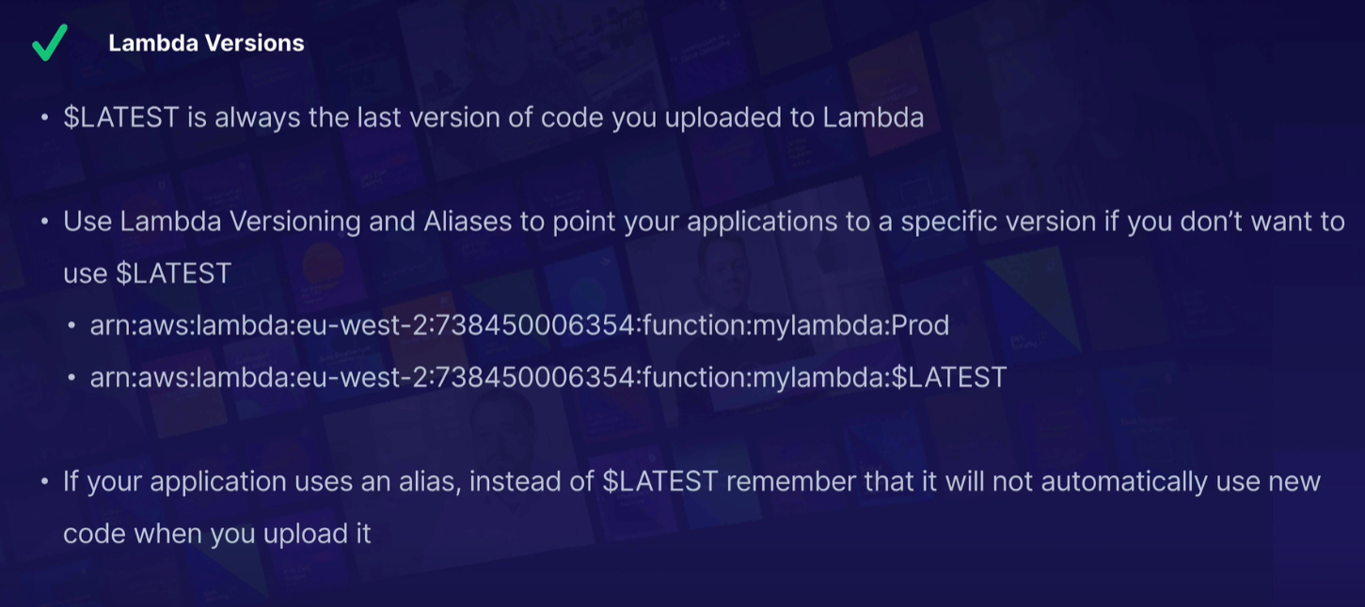

Lambda Concurrent Execution Limit:

* It is the number of Lambda functions that can be run simultaneously within the same region
* Concurrent Executions default value is 1,000 per region. If you hit the limit, you will get TooManyRequestsException with HTTP Status Code: 429
* If required we can request limit to be exceeded
* ** If you have many Lambda functions running in the same region and you suddenly start seeing new invocation requests being rejected, then you may have hit your limit
* Reserved Concurrency guarantees a set number of concurrent executions are always available to a critical function

Q:You have created a serverless application which converts text into speech using a combination of S3, API Gateway, Lambda, Polly, DynamoDB and SNS. Your users complain that only some text is being converted, whereas longer amounts of text do not get converted. What could be the cause of this problem?

A: Your Lambda function needs a longer execution time. You should check how long is needed in the fringe cases and increase the timeout inside the function to slightly longer than that.

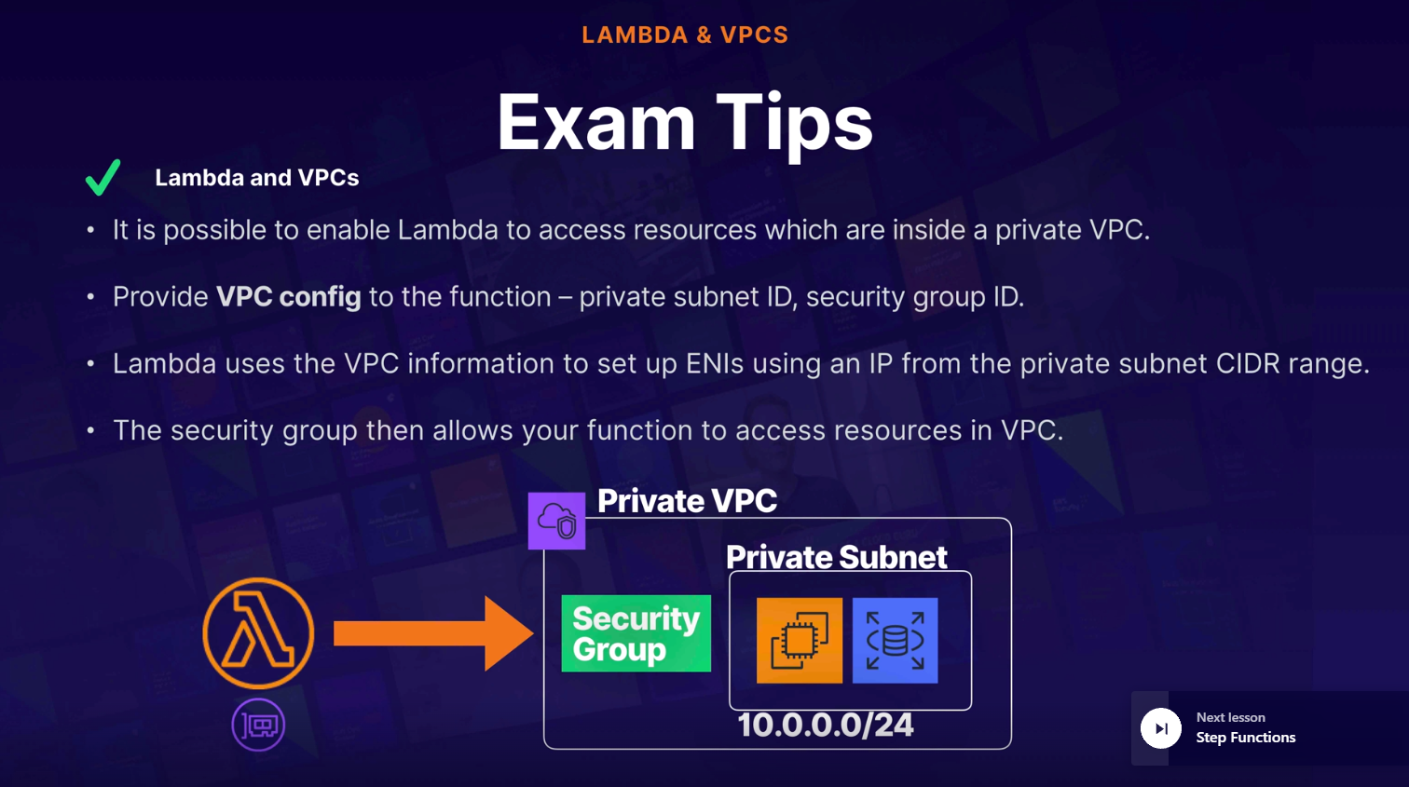

API Gateway:

API Gateway provides a single endpoint for all client traffic interacting with the backend of your application. When users make a request to use our AWS services the request hits our API Gateway first which forwards the request to appropriate service depending on the request.  
An API is like the front door to your application and API Gateway provides an endpoint to your application running in AWS.

* It allows you to connect to applications running on Lambda, EC2, or Elastic Beanstalk and services like DynamoDB and Kinesis.
* It supports multiple Endpoints and Targets so we can create multiple API endpoints and send different endpoint to a different target
* It also supports Multiple Versions and thus allows you to maintain multiple versions of your API, so you can have different versions for your development, testing, and production environments.
* API Gateway is serverless so it is low cost and scales automatically.
* Supports Throttling which prevents your application from being too overloaded.
* Everything is logged in CloudWatch.

You can import APIs using external definition files, e.g., OpenAPI, formerly known as Swagger.

When dealing with legacy applications which use SOAP, you can configure API Gateway as a SOAP web service passthrough, or you can use API Gateway to convert the XML response to JSON.

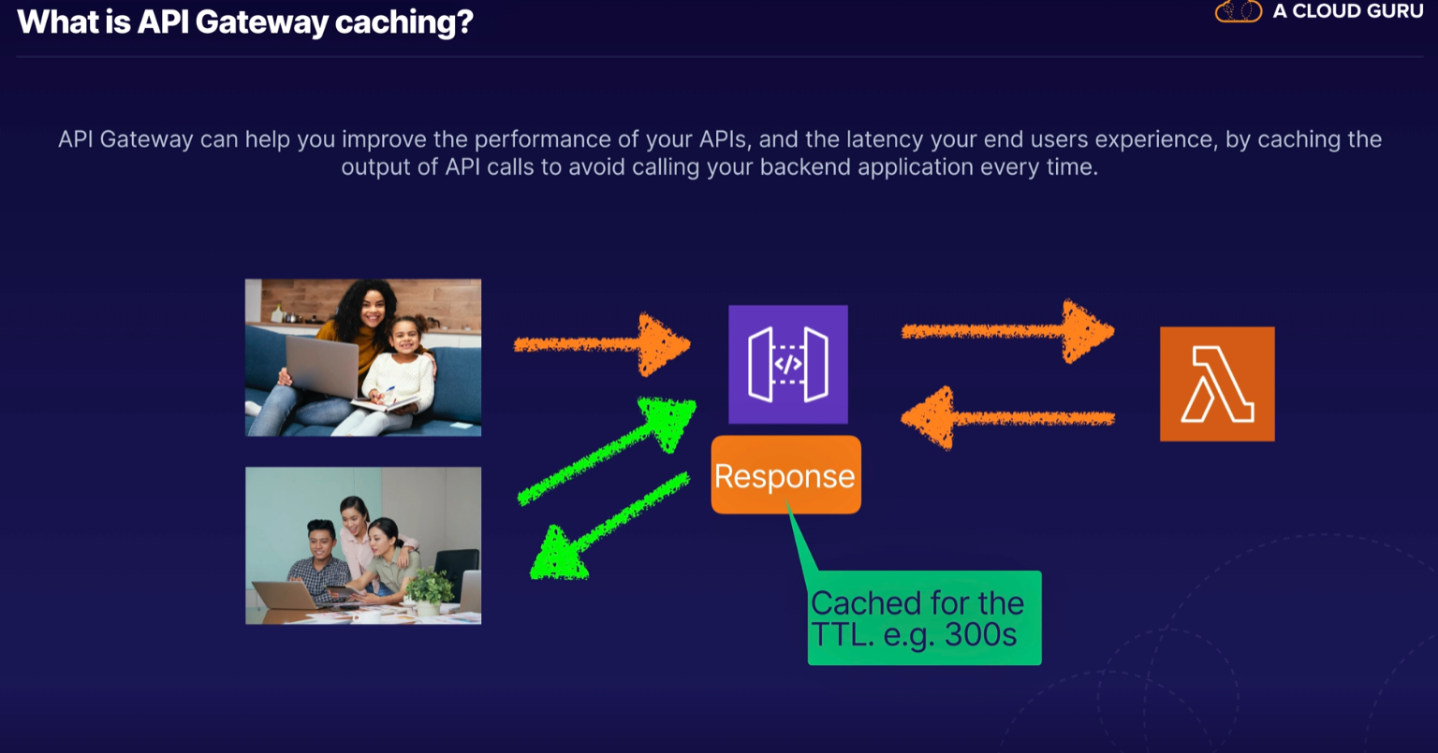

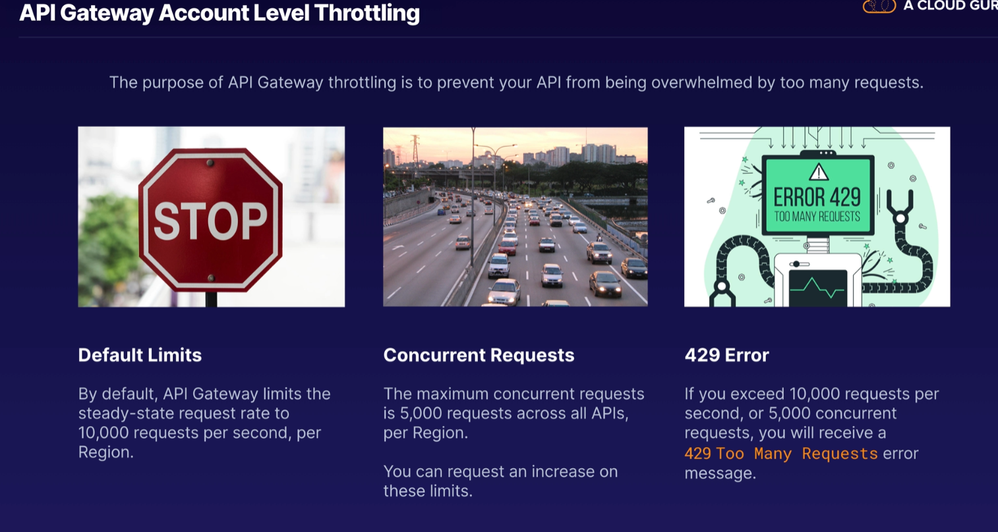

You have created an application using serverless architecture using Lambda, Api Gateway, S3 and DynamoDB. Your boss asks you to do a major upgrade to API Gateway and you do this and deploy it to production. Unfortunately something has gone wrong and now your application is offline. What should you do to bring your application up as quickly as possible?

* Rollback your API Gateway to the previous stage. (Ans). You can easily restore your AWS API Gateway from a previous deployment by selecting a stage that has the last version of your deployment.

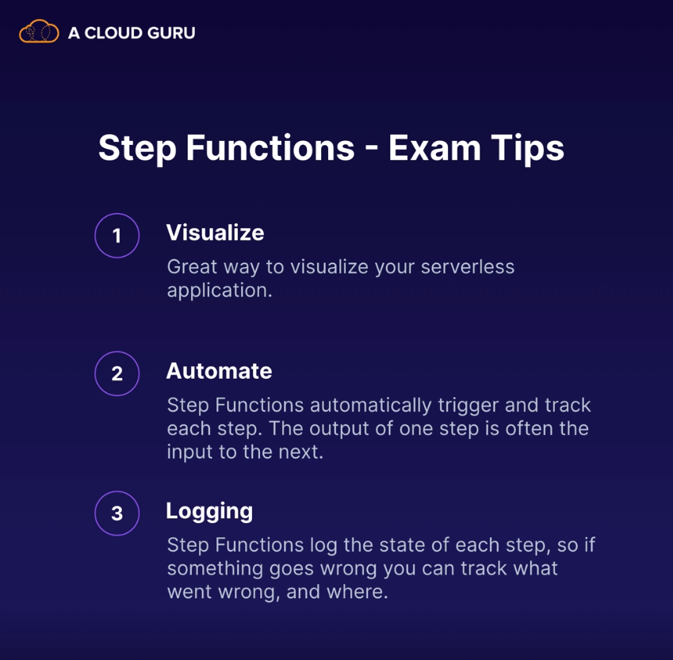

Step Functions Workflows:

Step Functions provides various types of state machines(a state machine is simply a workflow in step function) that feature different workflows to cater to a variety of tasks that you would like to orchestrate.

* Standard Workflow
  + Long-running, durable, and auditable workflows that may run for up to a year. Full execution history available for up to 90 days after completion.
  + Runs At-most-once
  + Tasks are never executed more than once (Non-idempotent)
* Express Workflow
  + Designed for short-lived workflows that lasts up to 5 mins. Great for high-volume, event-processing-type workloads.
  + Runs At-least-once
  + Tasks can be executed more than once (Idempotent)
  + Two types of Express Workflows: Synchronous Express Workflow & Asynchronous Express Workflow
    - Synchronous Express Workflow must complete before the next step begins (e.g., confirm successful payment before sending an order).
    - In Asynchronous Express Workflows other tasks are not dependent on the completion of the workflow (e.g., a messaging system).

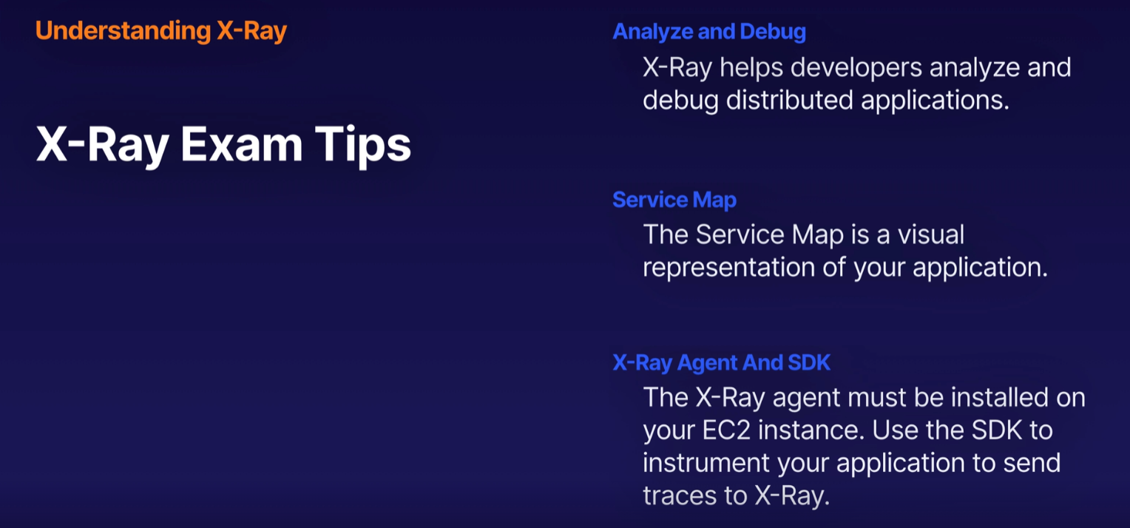

X-Ray Configuration Steps:

* X-Ray SDK has to be installed in the system which we want to monitor. The AWS X-Ray SDK sends the data to the X-Ray daemon (which also runs in the system) which buffers segments in a queue and uploads them to X-Ray in batches.
* You need both the X-Ray SDK and the X-Ray daemon on your systems to sent data into X-Ray

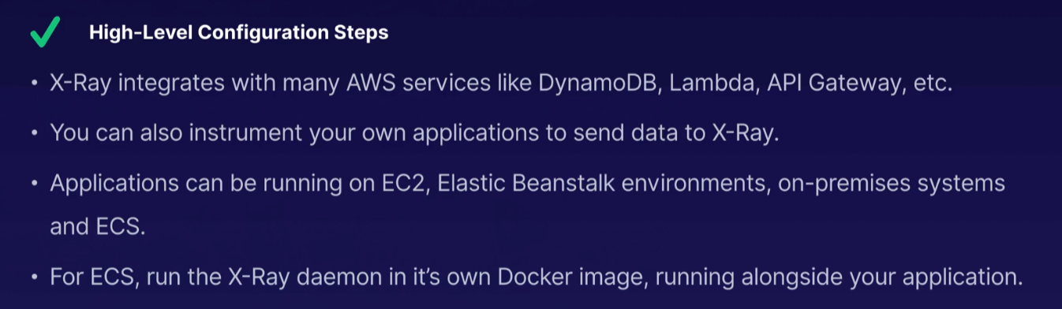  
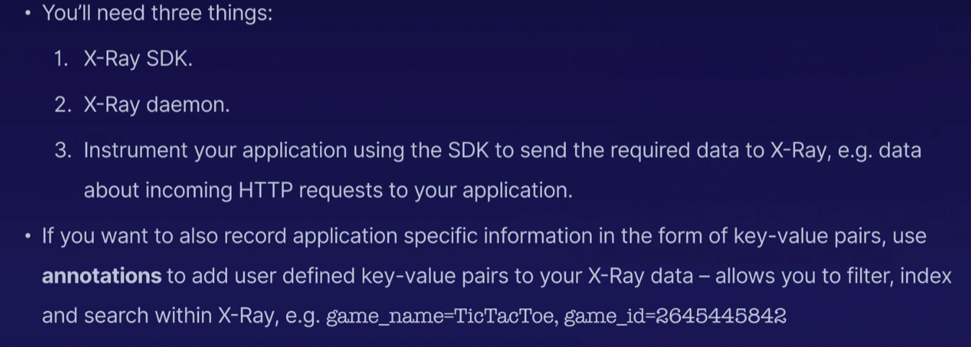

You would like to use X-Ray to monitor your application which runs on a number of Docker containers. Where should you deploy and run the X-Ray daemon? 🡪 Use a dedicated Docker container build from an image which includes the X-Ray daemon. X-Ray provides a Docker container image that you can deploy alongside your application. For custom configurations, you may need to define your own Docker image.

**SQS:**

It is a distributed messaging queue service. It enables web service applications to quickly and reliably queue messages that one component in the application generates for another component to consume.   
A queue is a temporary repository for messages awaiting processing.  
SQS acts as a buffer between the component receiving the data for processing and the component producing the data and resolves Scheduling Issues which arrives if the producer is producing work faster than the consumer can process it.

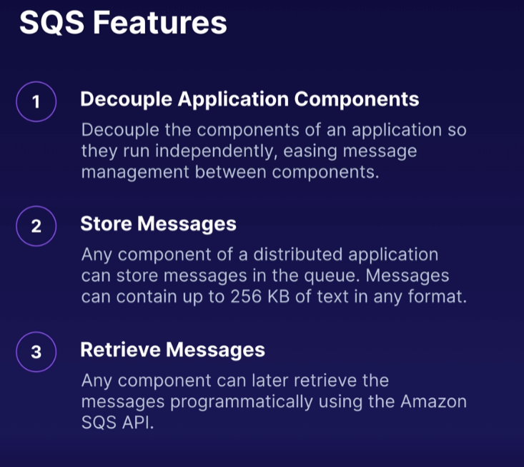

Two types of SQS Queues –

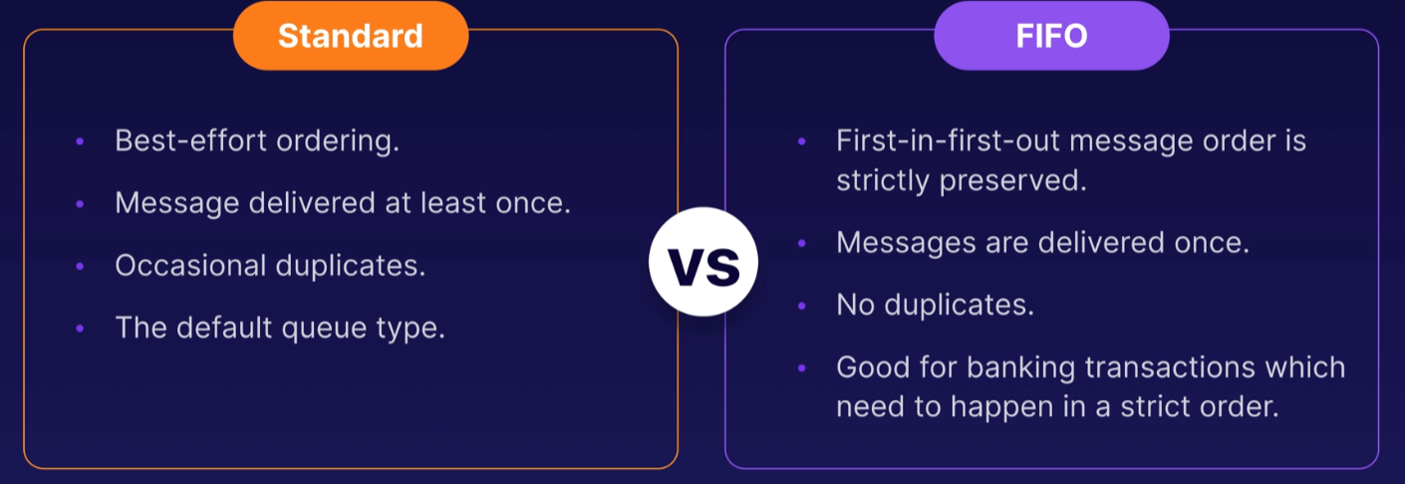

Visibility Timeout:

Visibility timeout is the amount of time that the message is invisible in the SQS queue after a reader or consumer picks up that message for processing. By default, Visibility Timeout is 30 secs.   
Ideally, the job will be processed before the visibility time out expires, and the message will then be deleted from the queue. If the job is not processed within that time, the message will become visible again and another reader will process it.

Visibility Timeout can be increased from the default 30 seconds and maximum timeout can be up to 12 hours.

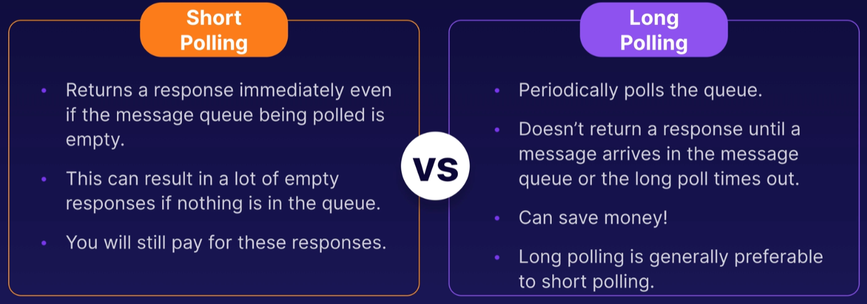

SQS Delay Queues – postpone delivery of new messages

* Postpone delivery of new messages to a queue for a number of seconds
* Messages sent to the Delay Queue remain invisible to consumers for the duration of the delay period
* Default delay is 0 seconds, maximum is 900
* For standard queues, changing the setting doesn't affect the delay of messages already in the queue, only new messages
* For FIFO queues, this affects the delay of messages already in the queue

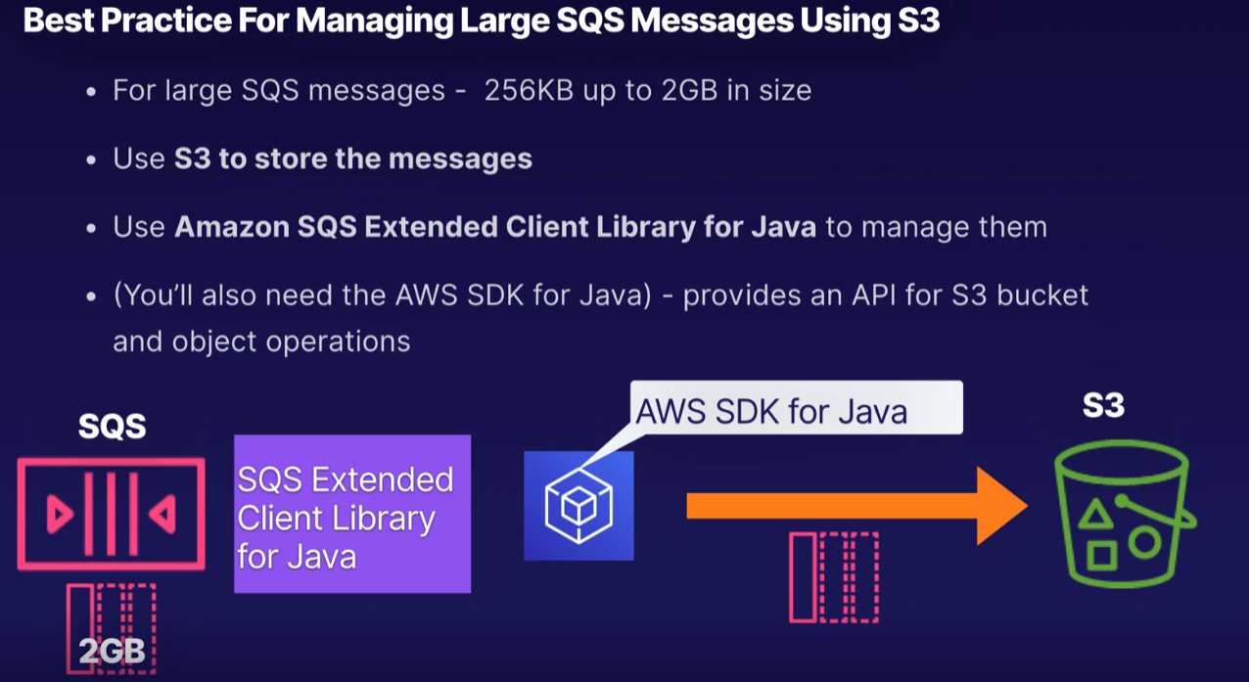

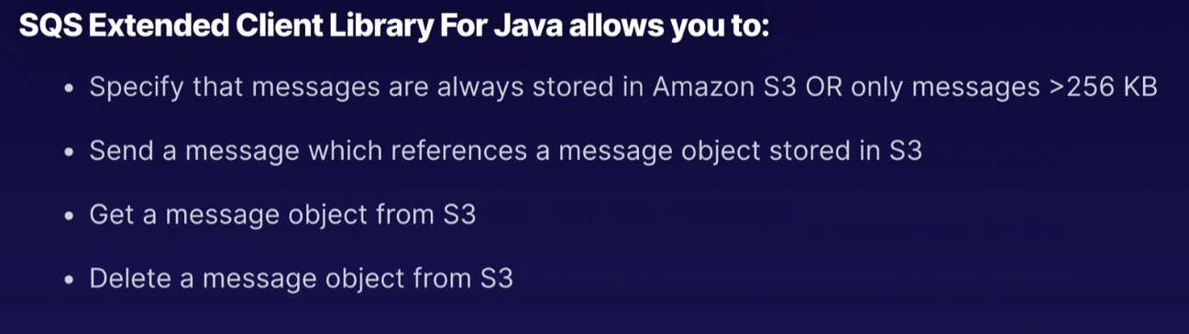

**SNS – Simple Notification Service:**

SNS is a web service that makes it easy to set up, operate, and send notifications from the Cloud. Messages sent from an application can be immediately delivered to subscribers or other applications.

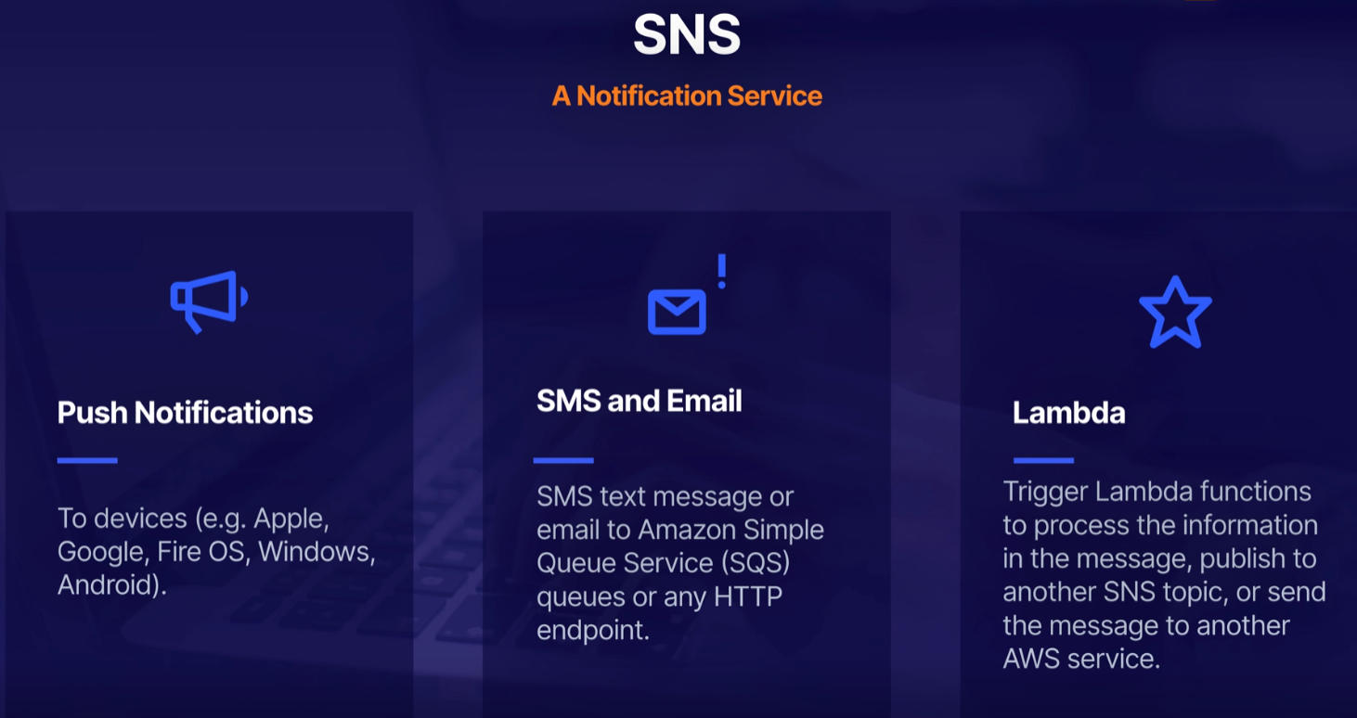

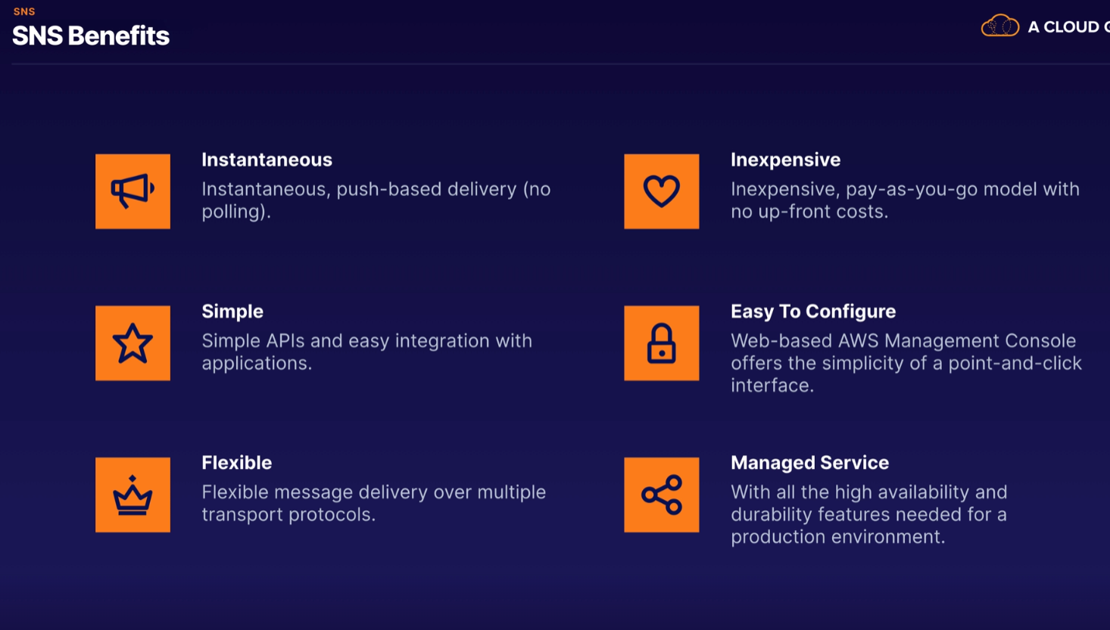

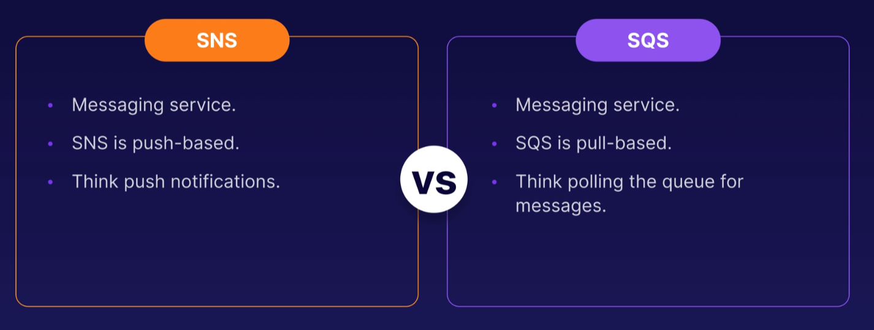

Push-based meaning SNS pushes the messages/notification out to users/application.

Pull-based meaning any application which needs to consume messages from SQS needs to actively pull the queue to access the messages.

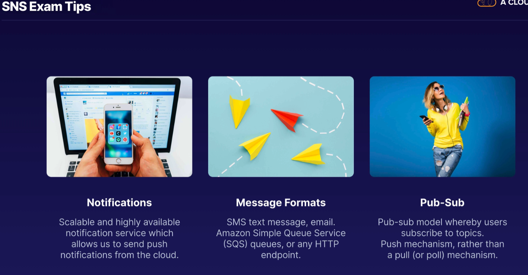

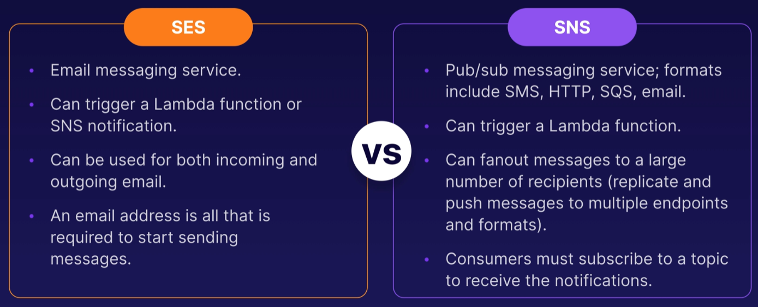

**Developer Theory:**

CI/CD stands for Continuous Integration and Continuous Deployment/Delivery. AWS services help us with CI/CD.

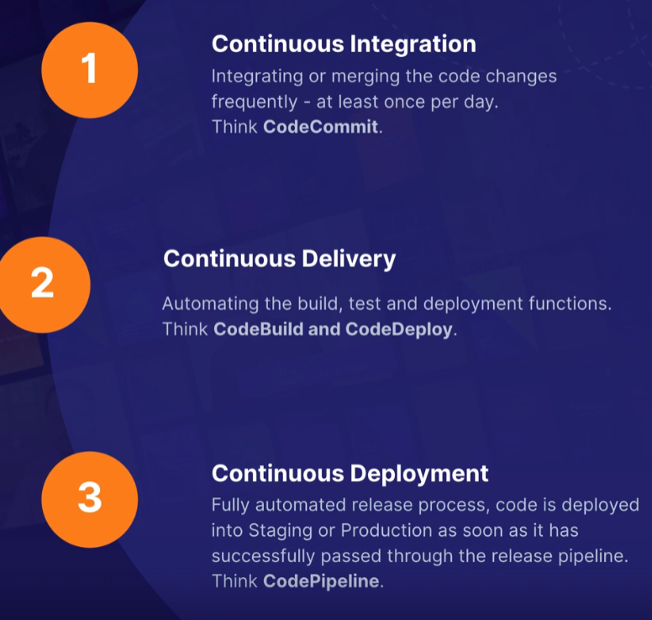

**CodeCommit:**

CodeCommit is a Central Code Repository i.e., it’s a place to store source code, binaries, libraries, images, HTML files etc. It is based on Git.

* It allows multiple developers to work on the same code at the same time
* Enables collaboration – manages updates from users
* Tracks and manages code changes
* Maintains version history

**CodeBuild:**

It compiles source code, runs tests and produces packages that are ready to deploy.pp

**CodeDeploy:**

CodeDeploy is automated deployment service it works with EC2 instances, on-premises and lambda.

* Quickly release new features.
* Avoid downtime during deployments.
* Avoid the risks associated with manual processes.

CodeDeploy Deployment Approaches –

In-Place Deployment:

The application is stopped on each instance and the new release is installed. Also known as a Rolling Update.

* The application is stopped on the first instance.
* The instance will be out of service during the deployment so capacity is reduced.
* You should configure your Elastic Load Balancer to stop sending requests to the instance
* CodeDeploy installs the new version, known as a Revision.
* The instance comes back into service.
* CodeDeploy continues to deploy to the next instance.

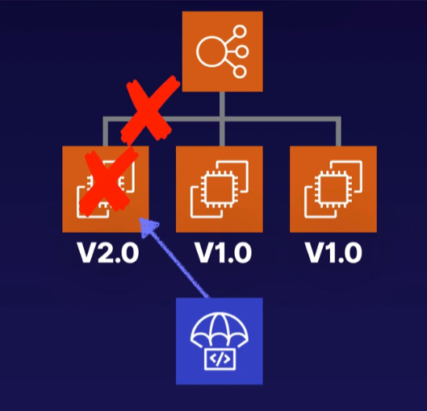

Blue/Green Deployment:

New instances are provisioned and the new release is installed on the new instances. Blue represents the active deployment; green is the new release.

* Blue represents the current version of our application.
* CodeDeploy provisions new instances.
* The new Revision is deployed to the Green environment.
* The Green instances are registered with the Elastic Load Balancer.
* Traffic is routed away from the old environment.
* The Blue environment is eventually terminated.

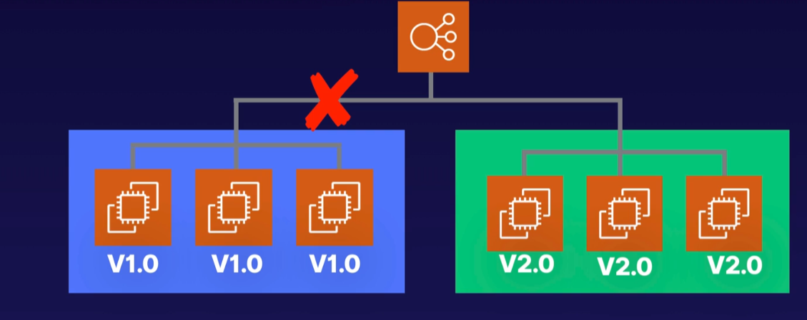

CodeDeploy AppSpec File:

It is a configuration file which defines the parameters to be used during a CodeDeploy deployment. For deployment on EC2 and on-prem systems the AppSpec file can be written in YAML only but for Lambda both YAML and JSON is supported.

EC2 AppSpec File Structure consist of Version, OS that is used, Files - location of any application files that needs to be copied and where they should be copied to, and Hooks – scripts which need to run at set points in the deployment lifecycle.   
Life-Cycle Event Hooks allows us to run scripts at specific points during the deployment by using different Run Orders.

Different Run Orders:

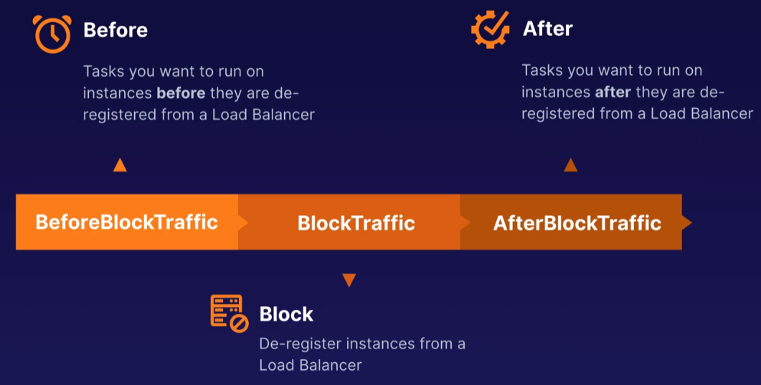

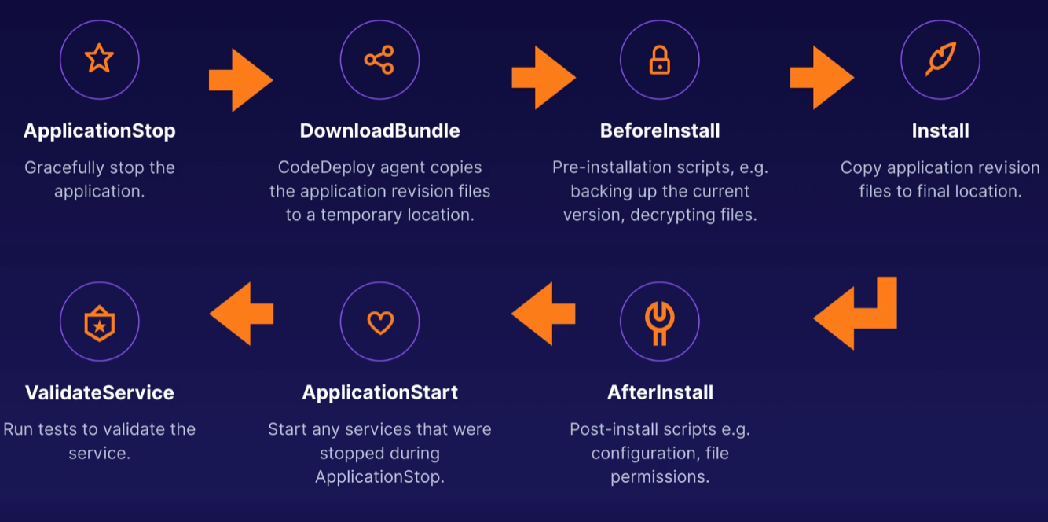

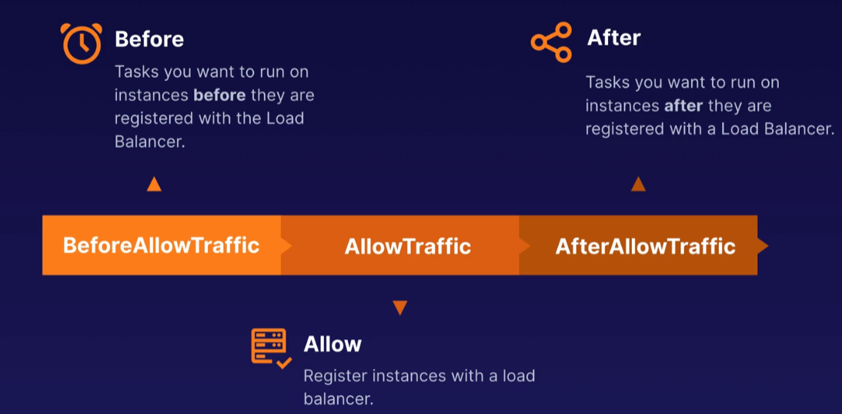

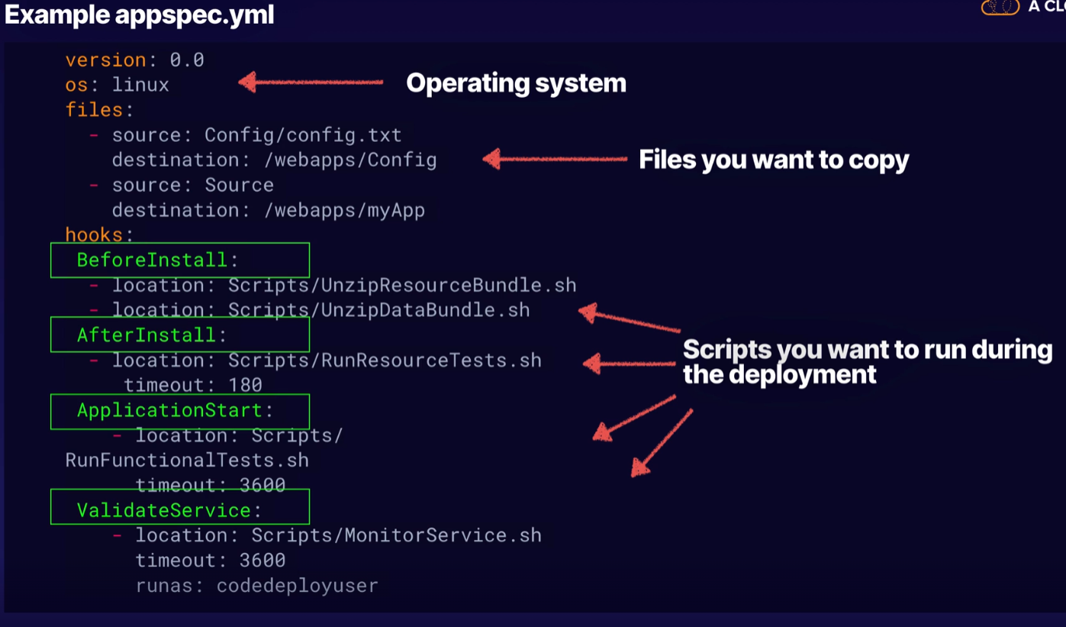

The appspec.yml must be placed in the root of the directory of your Revision, otherwise the deployment will fail.

CodePipeline:

It is a fully managed Continuous Intregation/ Continuous Delivery Service which automates the Build, Test and Deployment stages of software release process. It automatically triggers your pipeline as soon as a change is detected in your source code repository. CodePipeline integrates with - CodeCommit, CodeBuild, CodeDeploy, Github, Jenkins, Elastic Beanstalk, CloudFormation, Lambda, Elastic Container Service.

CodeArtifact:

A central repository that can be used by all your developers to obtain the correct versions of the software packages required for their projects.  
Artifact Repository allows us to securely store, publish and share artifacts related to your application.  
An Artifact includes Documentation, Compiled Applications, Deployable Packages, Libraries.

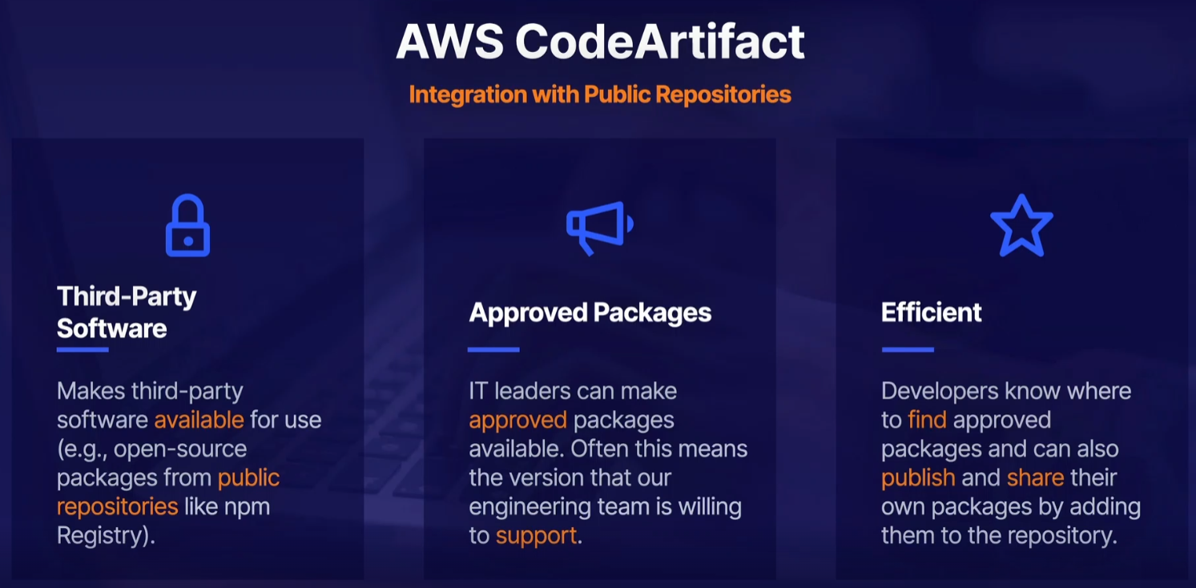

If you want to pull packages from an external public repository, create an upstream repository with an external connection to the public repository (e.g., the npm registry for Node.js packages).

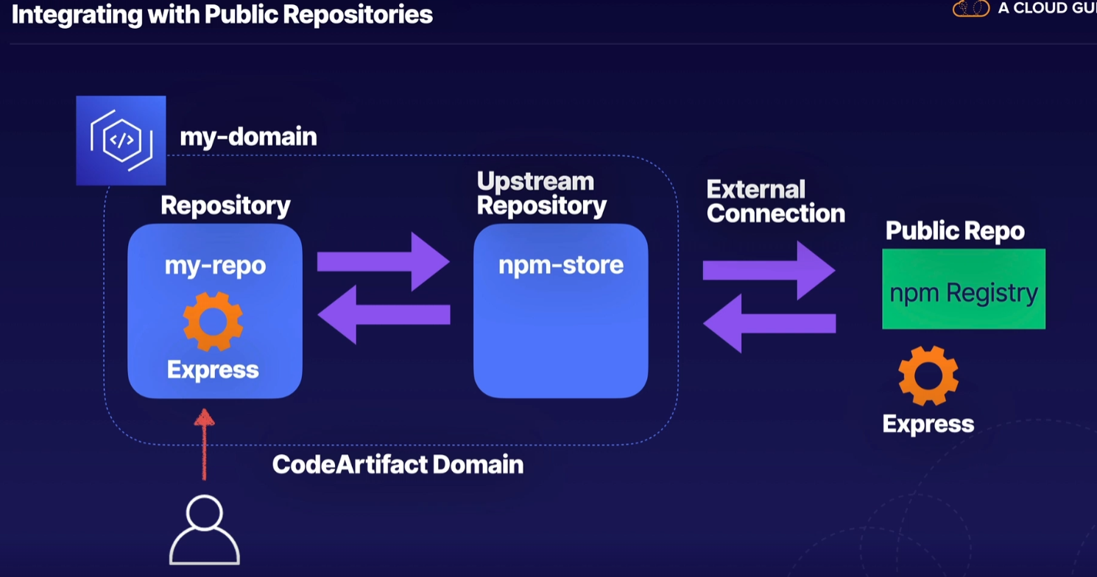

Elastic Container Service:

ECS is a container orchestration service which supports Docker and Windows Containers.

It enables us to quickly deploy and scale containerized workloads without having to install, configure, manage and scale your own orchestration platform. It is similar to Kubernetes, but with deep integration with AWS services e.g. IAM, VPC, Route53.

We can run ECS on either EC2 Instances or Fargate.  
Fargate is used for serverless containers where you don’t needto worry about the underlying EC2 instance.  
But for more control EC2 instances is used i.e. if you want to control the installation, configuration and management of your compute environment.

Elastic Container Registery:

ECR is a CONTAINER REGISTRY

This is where you can store your container images. Docker or Windows Container

Deploying Docker Using Elastic Beanstalk:

Elastic Beanstalk & Docker Containers

* Elastic Beanstalk supports the deployment of Docker containers.
* Docker containers are self-contained and include all the configuration information and software your web application requires to run like libraries, system tools, code & runtime environments
* Elastic Beanstalk handles the capacity provisioning, load balancing, scaling, and application health monitoring.

When we deploy a docker container using Elastic Beanstalk,

* You can either run a Single Docker container on an EC2 instance provisioned by Elastic Beanstalk
* Use Elastic Beanstalk to build an ECS cluster and deploy Multiple Docker Containers on each instance
* To deploy a Docker application just upload your code bundle to Elastic Beanstalk.
* To upgrade your application to a new version, it's one easy step in the console to upload and deploy your new version.
* Code can be uploaded directly from your local machine or a public S3 bucket.
* You can also store your code in CodeCommit-but must use the Elastic Beanstalk CLI.

**CloudFormation:**

CloudFormation allows you to manage, configure and provision AWS infrastructure as code. YAML and JSON are only supported as CloudFormation template code.

Benefits-

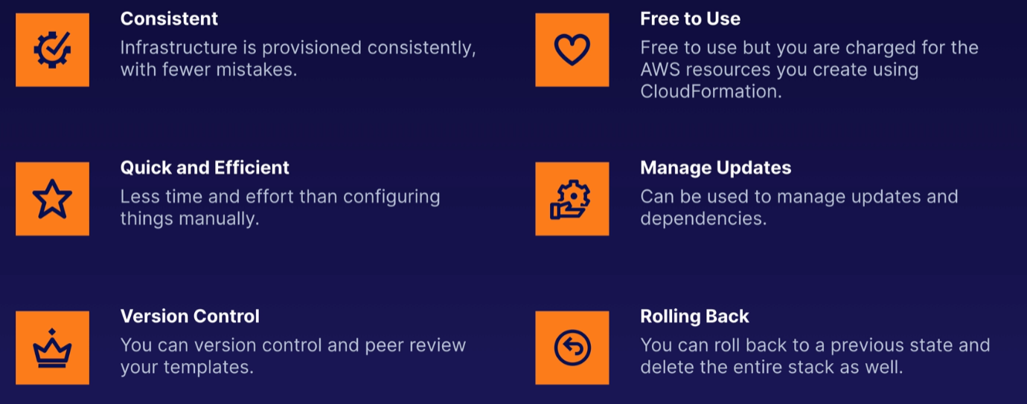

CloudFormation Process:

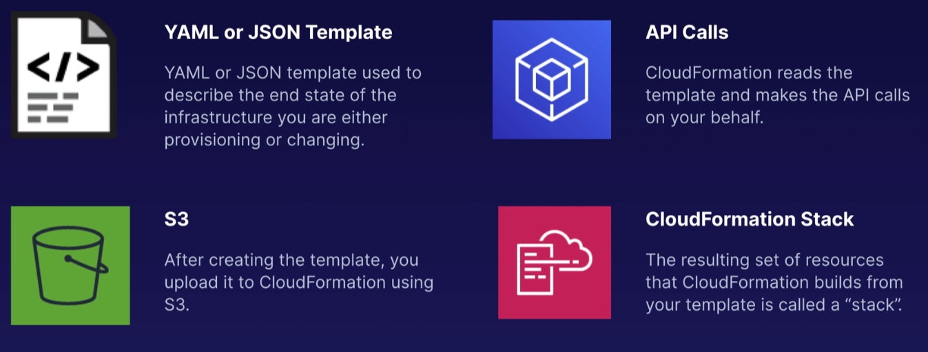

The Resources Section is Mandatory - Resources is the only mandatory section of the CloudFormation template

The Transform Section is for Referencing Additional Code - The Transform section is used to reference additional code stored in S3, allowing for code re-use.  
E.g., Lambda code or template snippets/reusable pieces of CloudFormation code.

Main Sections of Cloudformation Template –

Parameter – which allows you to input custom values like ‘EnvType’ which refers to environment type

Conditions – used to make decisions based on a set of parameter

Resources – mandatory section, defines all the AWS resources to be created

Mapping

Transform – allows you to reference code located in S3

Exporting CloudFormation Stack Values:

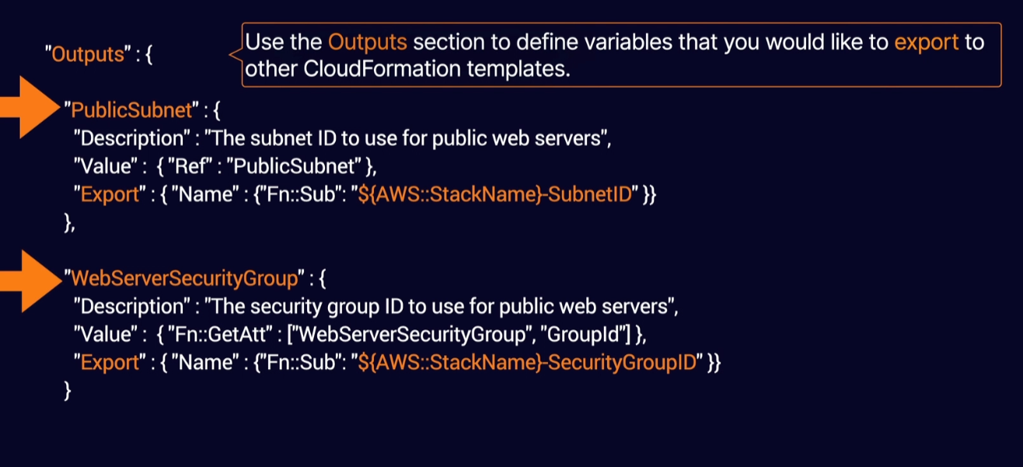

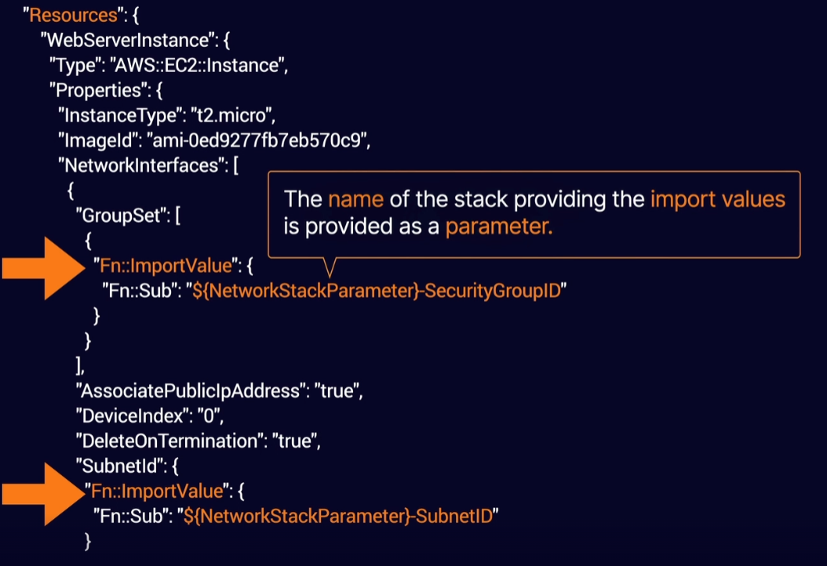

SAM(Serverless Application Model) –

* It is extension to CloudFormation and used specifically to define and provision serverless applications i.e. CloudFormation for serverless.
* SAM uses a simplified syntax for defining serverless resources: APIs, Lambda Functions, DynamoDB tables etc.
* SAM also has its own command line interface SAM CLI to package your deployment code, upload it to S3 and deploy your Serverless Application. The SAM CLI commands are –
  + sam package – to package your application and upload a deployment file to S3
  + sam deploy – to deploy your serverless application using CloudFormation

CloudFormation Nested Stacks –

* Code Re-use – allows you to reuse your CloudFormation code so you don’t need to copy/paste every time and just reference it from the Resources section of any CloudFormation template.
* The template must be located in a S3 bucket

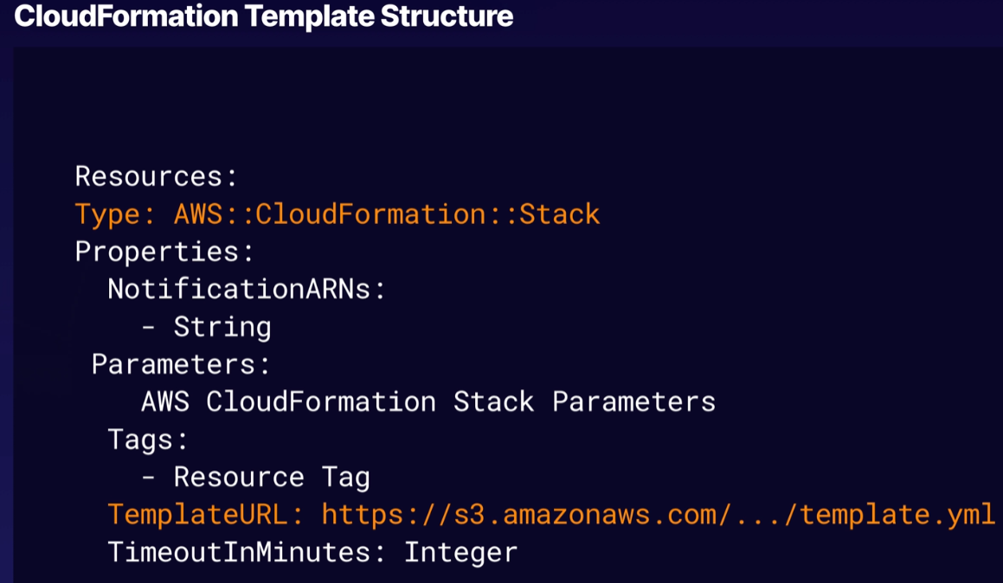

**Advanced IAM:**

Web Identity Federation –

* It gives users access to AWS resources after successfully authenticating with a web-based identity provider like Facebook, Amazon etc.
* it allows users to authenticate using a web identity provider like Google, Facebook, Amazon etc., following successful authentication the user receives an authentication code from the web ID provider which they use to get a temporary AWS security credential for authorizing access to AWS resources.

Amazon Cognito –

* this AWS service provides Web Identity Federation, including sign-up and sign-in functionality for your application and access for guest users.
* It manages the authentication between your application and Web ID provider (google, facebook), without having to write any addition code in your application for your users to sign up or sign in to your application using Web ID provider.
* Synchronizes user data across multiple devices.
* AWS Cognito is recommended for all mobile applications what calls AWS services.
* Working – users authenticate using Web ID provider, after successful authentication (an authentication token/JWT token is exchanged b/w Web ID provider and Cognito) Cognito provides temporary AWS credentials which are mapped to IAM roles allowing access to AWS resources
* No need to application to store AWS credentials locally on device.

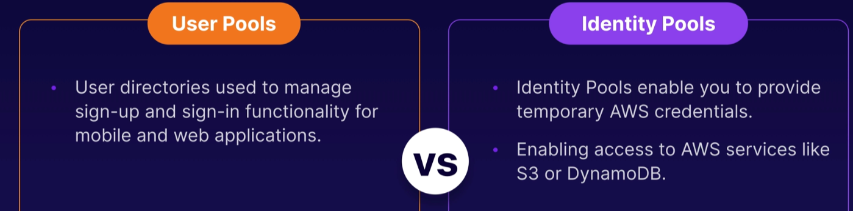

AWS Policies – Inline, AWS Managed and Customer Managed Policies:

AWS Managed Policies – are IAM policies which are created and administered by AWS i.e., AWS managed default policies. These policies are non-editable. Can be attached to multiple users, groups or roles.

Customer Managed Policies – are IAM policies that are created, managed by the user/customer. These policies are editable. Can be attached to multiple users, groups or roles.

Inline Policies - are IAM policy which are embedded within the user, group or role to which it applies. Inline policies cannot be attached to multiple users, groups or roles, there is a strict 1:1 relationship b/w the policy and entity. When the user, group or role is deleted to which the inline policy is attached to, the inline policy also gets deleted.

STS and AssumeRoleWithWebIdentity API:

AssumeRoleWithWebIdentity is an API which is provided by STS (Security Token Service) which returns temporary security credentials for users authenticated by Web ID provider. If applications are not using AWS Cognito then this API can be used.

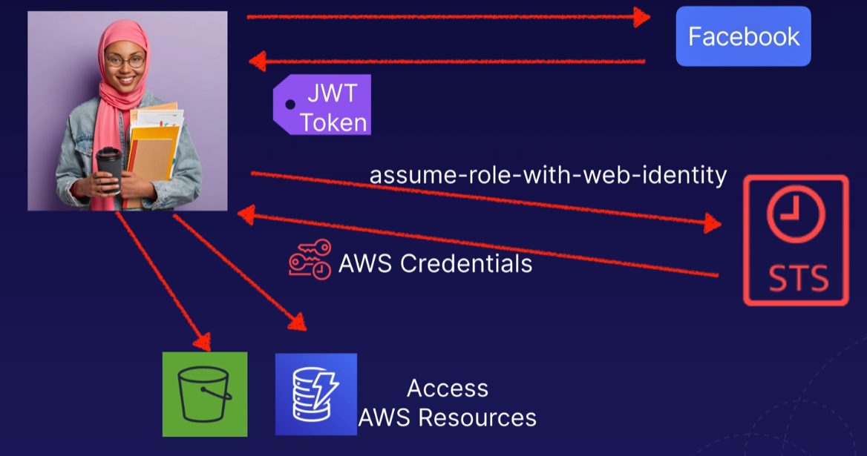

AWS Cross-Account Access:

* Helps to manage resources in other accounts and share resources in one account with users in a different account
* Cross-Account access can be set up using IAM roles, create a role in one account to allow access and grant permission to users in a different account.

